**SCHOLARSHIP PROGRAM MANAGEMENT SYSTEM FOR THE COMMISSION ON HIGHER EDUCATION – REGION 10**

**CHARISSE AVEGAIL B. DE GUZMAN**

**MARC ANTHONY C. ESPIRITU**

**WERNEIL P. WEGMANN**

**MAY 2023**

**SCHOLARSHIP PROGRAM MANAGEMENT SYSTEM FOR THE COMMISSION ON HIGHER EDUCATION – REGION 10**

**-------------------------------------------------------------------------------**

A **Capstone Project** Presented to the

College of Information Technology

Liceo de Cagayan University

Cagayan de Oro City

**-------------------------------------------------------------------------------**

In Partial Fulfillment

of the Requirements for the Degree

**Bachelor of Science in Information Technology**

**-------------------------------------------------------------------------------**

**CHARISSE AVEGAIL B. DE GUZMAN**

**MARC ANTHONY C. ESPIRITU**

**WERNEIL P. WEGMANN**

**CHAPTER 1**

**THE PROBLEM AND ITS SCOPE**

# Introduction

 Scholarship program is a type of financial aid that allows students to pursue higher education. These program, which typically funded by government agencies, private organizations, or academic institutions, are intended to help students who have demonstrated academic excellence, financial need, or other specific criteria. With tuition and related expenses on the rise, scholarship programs play an important role in ensuring that students from all backgrounds have access to education and opportunity to achieve their goals.

A monitoring system is a tool or process for collecting, analyzing, and reporting data on the performance or status of a specific system, process or activity. It is intended to provide real-time data to support decision-making, identify potential problems or issues, and track progress over time. Monitoring system’s primary objective is to enhance effectiveness, reliability, and security by providing stakeholders with the information they require to make informed decisions and take appropriate action.

According to a study conducted by Ibrahim (2020), government scholarships play a significant role in promoting education and human capital development. The study found that government scholarships provide opportunities for individuals who may not have been able to afford higher education, thereby increasing access to education for marginalized groups. Additionally, government scholarships have been shown to have a positive impact on the economic development of a country by producing highly skilled and educated individuals who contribute to the workforce. Furthermore, government scholarships have been found to be effective in promoting diversity and inclusion within educational institutions. These findings suggest that government scholarships can be an effective tool for promoting education and human capital development, as well as promoting economic growth and diversity.

In a study conducted by Wehrich and Koontz (2018), it was observed that financial monitoring are relied upon by companies in their daily activities to assess the actual performance of the organization in comparison to budgeted expectations. This reliance on financial reports demonstrates the significant contribution of financial information in assisting decision-makers to make optimal decisions. Financial reports provide decision-makers, such as managers and executives, with key insights into various aspects of the company's operations, including revenue, expenses, assets, liabilities, and cash flows. These reports allow decision-makers to evaluate the financial health of the organization, monitor performance against objectives, identify trends, and assess risks and opportunities.

The Commission on Higher Education (CHED) in Region 10, based in Cagayan de Oro City, is crucial for guaranteeing that Higher Education Institutions (HEI) in Northern Mindanao provide students with a quality education. CHED, as a regulatory body, ensures that these institutions meet national standards and provides assistance to help them improve the quality of their programs, such as the Scholarship program. Its presence in Region 10 provides the essential foundation for the region's higher education system, ensuring that students have access to high-quality education that will prepare them for success in their chosen careers.

The Scholarship Program of the (CHED) Region 10 is essential for providing financial assistance to students. However, interested applicants had to apply via Google Forms and physically submit their requirements and application forms, which were then evaluated and verified by CHED personnel. The manual process of the scholarship programs has resulted in inefficiencies and difficulties for both CHED personnel and applicants. Because the volume of applications was high, and the evaluation process was time consuming. Communication between CHED and applicants was limited since updates and notifications had to be done manually.

The development of a scholarship program management system for CHED-Region 10 that automates the application and evaluation processes. This system would monitor and process scholarship data and transactions with efficiency, reliability, and effectiveness. By implementing this system, CHED Region 10 would be able to provide better and more accessible financial assistance to students in Northern Mindanao, thereby improving the region's overall higher education system. The development of this scholarship program management system is an important step toward modernizing and digitalizing CHED Region 10's scholarship program, ensuring its effectiveness and relevance in the face of changing needs and challenges.

**Framework**

The Input-Output (IPO) Model is a functional graph that identifies the inputs, outputs, and required processing tasks required to transform inputs into outputs. The model is sometimes configured to include any storage that might happen in the process as well. The inputs represent the flow of data and materials into the process from the outside. The processing step includes all tasks required to effect a transformation of the inputs. The outputs are the data and materials flowing out of the transformation process. [[What is the Input-Output Model | Input Output Model Examples (sixsigmadaily.com)](https://www.sixsigmadaily.com/input-output-model/#:~:text=The%20Input%2DOutput%20(IPO),in%20the%20process%20as%20well.)]

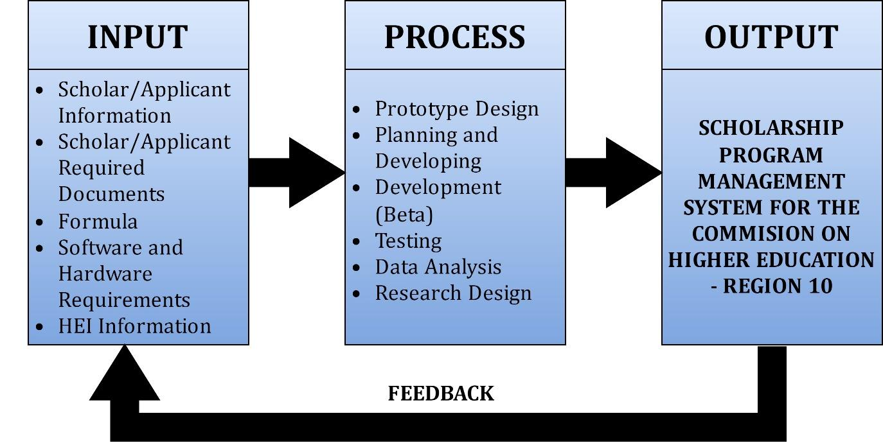

***Figure 1.*** *Conceptual Paradigm of the Study*

Figure 1 illustrates how the proposed project is developed. Input data such as student’s information, documents, grades, and parent income. For the process of CHED Scholarship Program, the Prototype Design is the creation of preliminary model of the web. Planning and developing in the context of web design it involves defining goals, conducting research, and users’ needs and requirements. Data Analysis is the process of systematically examining and interpreting data. The output of the entire process is the SPMS for the CHED– Region 10.

**CSP Eligibility Requirements**

The Commission on Higher Education has a standard scholarship requirements and criterion.

***Figure 2.*** *Scholarship Application Qualification and Requirements*

The availment of the type of scholarship is determined through ranking system and availability of slots.

**Financial Assistance**

The financial assistance will cover the tuition and other school fees (TOSF), stipend, and book/connectivity allowances per semester which will be released directly to the scholars through the HEIs.

Below is the list of the financial packages for the Full and Half Merit Scholars:

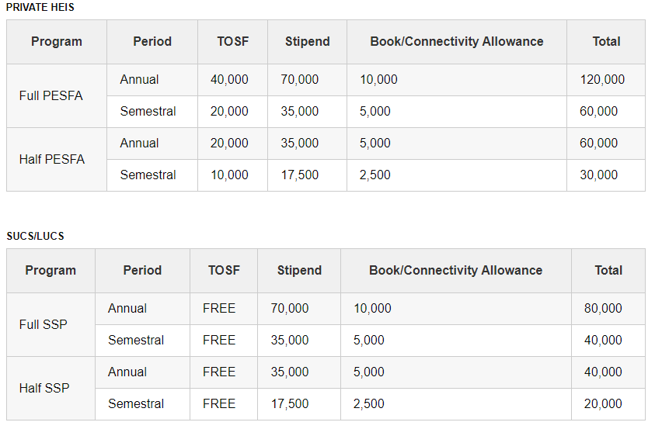

***Figure 3.*** *Financial Packages for the Full and Half Merit Scholars*

**Point System and Formula for Scholarship Qualification**

**Table 1. Grade**

|  |  |  |
| --- | --- | --- |
| Range (%) | | Eqv. Points |
| 99 | 100 | 100 |
| 97 | 98 | 95 |
| 95 | 96 | 90 |
| 93 | 94 | 85 |
| 91 | 92 | 80 |
|  | 90 | 75 |

***Table 1. Grade Equivalent Points***

Table 1 contains the grade range percentage from 90 to 100 and it has an equivalent points for the criteria of ranking.

**Table 2. Income**

|  |  |  |
| --- | --- | --- |
| Range (Pesos) | | Eqv. Points |
| 0 | 70,000.00 | 100 |
| 70,001.00 | 136,000.00 | 95 |
| 136,001.00 | 202,000.00 | 90 |
| 202,001.00 | 268,000.00 | 85 |
| 268,001.00 | 334,000.00 | 80 |
| 334,001.00 | 400,000.00 | 75 |

***Table 2. Annual Gross Income Equivalent Points***

Table 2 illustrates the annual gross income range from 0 – 400,000.00 and its equivalent points for the criteria of ranking.

|  |  |  |  |  |
| --- | --- | --- | --- | --- |
| Given | | Equivalent Points | % Weight | Computed Score |
| a | b | c | d | e = (c x d) |
| Grade | 95 | 90 | 70% | 63 |
| Income | 200,000.00 | 90 | 30% | 27 |
| **Rank Score** |  |  | **100%** | **90** |
| plus | Solo Parent |  |  | 5 |
| **Total Rank Score** |  |  |  | **95** |

**Table 3. Sample Illustration**

***Table 3. Sample Illustration***

Table 3 illustrates the sample illustration of how to compute the rank score of a student.

**Formula for Ranking**

**e = (c x d)** *per given grade and income*

*where:*

*a = applicant grade*

*b= family income*

*e* = represents the rank score

*c* = represents the equivalent points based on grade and income

*d* = represents the percentage weight assigned to *a* and *b*

*cg* = computed score for grade

*ci* = computed score for income

*trs =*  rank score

**Sample Computation Score for Grade**  
if *a* = 95 then

*c*  = 90

*d = 70%*

*cg = 90 x 70%*

*cg = 63*

**Sample Computation Score for Income**

if *b* = 200000 then

*c*  = 90

*d = 30%*

*ci = 90 x 30%*

*ci = 27*

**Sample Computation for Total Rank Score**

if solo parent then

*trs = cg + ci + 5*

*trs = 63+27+5*

*trs = 95*

***else***

*trs = cg + ci*

*trs = 63 + 27*

*trs = 95*

**Statement of the Problem**

The study aims to address the following problems:

* The scholarship program requires printed documents that will occupy storage space;
* Monitoring and tracking of scholarship transactions requires a lot of working hours;
* Paper based storage of data is prone to unauthorized access; and
* The delay in generating reports may be due to the manual process.

**Objective of the Study**

**General Objective**

The general objective of this study is to develop a SPMS for the CHED in Region 10, with the goal of improving access, accuracy, and timeliness of scholarship data and transaction flow. The system will provide real-time updates and efficiently generate reports, enabling faster and more streamlined processes

**Specific Objective**

To achieve the general of the study, the research needs to achieve the specific goals;

* To create a data storage for scholarship application;
* To develop a monitoring and tracking that would easily and efficiently track scholarship transactions;
* To create an application with security features that requires users access privilege; and
* To develop and implement a real-time automated reporting system.

**Scope and limitations of the Study**

The CHED Scholarship Program Management System will be responsible for the following tasks:

* collecting and processing scholarship applications;
* determining students' academic and financial eligibility;
* provide billing platform from HEI to CHED;
* Ensuring seamless application of the scholar until the completion of their studies;
* Scholarship and financial assistance/ allowance status; and
* Generation of CSP reports.

The study will not cover liquidation and disbursement of scholars financial assistance.

**Significance of the Study**

The result of the study would be beneficial to the following:

**Applicants/Scholars**. The study will be highly beneficial to the student applicants to easily apply the scholarship program.

**CHED- Region 10**. The study will be highly beneficial to the Commission on Higher Education in Region 10 to provide better support to scholarship recipients and ensure that scholarship programs are managed in an efficient, transparent, and effective manner.

**Higher Education Institutions.** The study will be beneficial to the Higher Education sector as it will improve their scholarship management systems, identify areas for improvement, and increase the impact of scholarship programs on student success.

**Government Agencies.** The study will be highly beneficial to the government agencies monitor the effectiveness of scholarship programs, ensure compliance with regulations, and develop policies to enhance access to education.

**Scholarship Coordinators.** The study will be highly beneficial to the Scholarship Coordinators to streamline their operations, ensure timely and efficient scholarship disbursement, and enhance their services to scholarship applicants and awardees.

**Private Sector.** The study will be highly beneficial to the private sector entities to identify opportunities to support scholarship programs, contribute workface development, and build their reputation as socially responsible organizations.

**Researchers.** The study will be highly beneficial to the researchers to develop and improve the skills of the researchers.

**Future Researchers.** The study will be highly beneficial to the future researcher for references.

**Output of the Study**

The output of the study is the Scholarship Program Management System, a fully functional software system that automates and simplifies the scholarship application process, selection process, and management and monitoring. The system will have features like an online application portal, real-time monitoring and secure storage of scholarship data and records. The software application can be easily integrated into CHED’s existing infrastructure, with clear documentation and user manuals provided to ensure smooth adoption and usage.

**Definition of Terms**

**Applicant-** a student who applies for scholarship.

**Application Process-** The procedures and requirements that an applicant must follow in order to apply for a scholarship program.

**CHED-** The Commission on Higher Education, a government agency in the Philippines responsible for promoting and regulating higher education institutions in the country.

**Criteria-** The specific requirements that an applicant must meet in order to be considered for scholarship program.

**Financial Assistance-** The provision of financial support to students to cover tuitions, fees, and other education-related expenses.

**Generates real-time reports-** The capacity to produce reports that take current data reports such as recipient lists that compile data an information relevant to scholarship programs.

**Management System-** The process of organizing, directing, and controlling resources (Including people, funds, and information) to achieve specific goals and objectives.

**Merit Scholarship -** is a type of scholarship awarded to students based on their exceptional academic achievements. In the context of the CHED Scholarship Program, a merit scholarship would likely be granted to students who have demonstrated outstanding academic performance, such as achieving high grades or rankings in their previous studies.

**Monitoring and Evaluation-** The process of assessing the effectiveness of scholarship programs, identifying areas for improvement, and making necessary adjustments.

**Region10 –** Also referred to as Northern Mindanao includes the provinces of Bukidnon, Camiguin, Lanao del Norte, Misamis Occidental, and Misamis Oriental.

**Scholarship Program-**A program that provides financial assistance to eligible students to pursue higher education.

**Selection Process-** The process of evaluating scholarship applicants and choosing the most qualified candidates for the program.

**CHAPTER 2**

**REVIEW OF RELATED LITERATURE**

This literature review aims to explore the implementation of various information systems, scholarship management systems and document tracking technologies to improve efficiency, transparency, and productivity in various industries. The review includes studies on mobile information systems, management information systems, accounting information systems, and geographic information systems and their impact on decision-making, data management, and crisis management. Specifically, the focus is on technologies that utilize agile methodologies, open-source software, RFID technology, and real-time monitoring to optimize document tracking in sectors such as universities, e-government, logistics, and procurement. This review also takes into account the challenges faced in implementing such systems, including technical expertise, system security, and user training, and highlights the potential benefits and drawbacks of using these technologies.

**Scholarship Management System**

Various studies have explored the implementation of scholarship management systems, such as web-based and mobile applications, to automate administrative tasks and improve the efficiency, transparency, and accountability of the scholarship process, while addressing challenges such as technical expertise, system security, and user training.

According to Aliyu and Abubakar (2019), scholarship management systems (SMS) have the potential to transform the scholarship process by improving the efficiency, transparency, and accountability of scholarship management. SMS can automate many of the administrative tasks involved in managing scholarship applications and awards, reducing the time and costs associated with manual processing. In addition, SMS can provide real-time tracking of scholarship application and award status, enabling applicants and scholarship providers to monitor the progress of the scholarship process. SMS can also enhance communication between scholarship providers and applicants, as well as provide a centralized platform for all scholarship-related documentation and communication. Despite the potential benefits of SMS, there are also challenges associated with its implementation, including the need for technical expertise, system security, and user training. Aliyu and Abubakar suggest that careful consideration of these issues is necessary for the effective implementation.

According to Jinto and Bibin(2018), the purpose of the proposed system is the use of a Scholarship Management System in colleges to automate the scholarship process and address the drawbacks of the existing system. This new system is designed to harness the speed and efficiency of computers to produce high-quality reports and records. Its main objectives are to decrease the time required to provide scholarships and lessen the amount of paperwork involved. The ultimate goal of the proposed system is to enhance the efficacy and efficiency of the scholarship process in colleges.

Al-Hawari, Alshawabkeh, and Abu Nawas (2019) presented a web-based examination management system that is designed using the Java enterprise edition three-tier architecture. The system allows for the definition and setup of exams based on a flexible tree-based exams structure and incorporates a rich text editor for composing exams suited for various language and engineering disciplines. The system automates scheduling, grading, and reporting processes to relieve instructors of these tasks. It also offers several security schemes that support multifactor authentication and authorization, prevent cheating, and detect impersonation. The system includes an informative wizard that enables students to take exams with ease. Results of the deployment of the system over the past three academic years illustrate its successful use in organizing online exams. User surveys confirm the system's user-friendliness, reliability, capability, cutting-edge technology, speed, and high availability.

Seidu (2017) aimed to enhance an existing web-based system that manages scholarship application process used by a non-government organization in Ghana. The NGO sponsors high school students and currently has a web-based application that keeps records of applicants, generates points, and sends letters to awardees. To broaden the scope of the system, this project added functionalities to track payments, transforming it from a Scholarship Application System to a Scholarship Management or Scholarship Fund Management System. The enhancements enable the NGO to process payments more efficiently, have a transparent payment system, generate reports, and reduce operational costs.

As per Falogme et al. (2017), the Scholarship office of a particular city needs to provide top-notch service to its clients. At present, the office staff rely on MS Excel to maintain records of students' profiles and funds. The head of the scholarship office examines the records and decides on the eligible candidates for scholarships. The screening process is stringent and requires the scholar applicant to be a bona fide resident of the city. However, using MS Excel is a time-consuming task, and the scholarship head spends a significant amount of time recording transactions every day. The task becomes more complicated because a massive amount of data related to the scholars needs to be updated regularly. It takes around a month or so for the scholarship head to update the records efficiently.

Plata et al. (2017) developed a web-based system and mobile application to manage data, transactions, and files for businesses or organizations. This system eliminates the need for paper work and allows for better communication. The Sagip-Eskwela Beneficiary Program Web-Based System and Mobile Application keeps records of students, their locations, and benefits received. The system generates reports on the quarterly transactions of benefits given, the status of students, reports of student beneficiaries in barangay or district, and archive information of those who finished the program. The system is expected to improve the Sagip Eskwela Program's record management, providing better service and benefits to recipients. Similarly, Mohammed (2015) developed an e-scholarship system that allows Niger State students across the country to apply for scholarships online. The system was designed using OOAD methodology and developed using PHP, AJAX, JavaScript, HTML as the front end and MySQL database as the backend. The e-scholarship system provides online application solutions, sends SMS alerts and emails on the progress of applications, saving time and increasing transparency.

Chavez et al. (2017) developed a management system that provides an efficient solution for an agency to manage and record their important documents. This system ensures the safety of records and eliminates problems like lost files, manual registration, expiration of blood stocks, inconsistent data, and lack of backup and recovery. The system was developed using Visual Basic 2010 for creating the graphical user interface and MS SQL for database management, which enables proper organization of data.

Malipol and colleagues (2018) developed an online scholarship application and record management system for an agency to streamline the manual process of managing and profiling scholars. The primary aim of the system is to enhance the current manual method used by the client and to expedite transactions. Implementing an application and record management system may also reduce manpower and result in more secure, reliable, and organized data storage. The developed system uses Microsoft Expression Web 4 as the programming language and XAMMP as the backend database to store all records. The system allows users to update their personal information, submit their credentials, and view the current status of their scholarship application. An administrator module is also provided, allowing the administrator to approve or disapprove applicant scholars and set schedules with ease. The system can generate and print reports as well.

An example of software that maintains data files in a computer system is a file management system. It is made to manage individual or group files, such as specialized office records and papers, however it only has a few functionalities. Report information, including the owner, the date of creation, the stage of completion, and other features helpful in an office setting, may be displayed. (Albacite et al., 2018/2021).

According to the study of Pastor (2019) The effectiveness of the organization depends on the management information system. Every organization's management information system should operate in accordance with its goals and objectives.

Alano et al. (2018) Thesis Management System is a platform for submitting prospective research works as well as a system that will make it easier to browse theses and other research works. The solution will also give the admin analytics so they may track the patterns of thesis document viewing.

The waterfall model can considerably increase the effectiveness and quality of software development based on the small-scale management system of the SSM architectural paper and generally reliable software requirements. (Wang et al., 2018).

According to Zia, M. F., Elbouchikhi, E., & Benbouzid, M. (2018)., renewable energy resources are being used on a large scale to meet increased energy demand while mitigating environmental pollutants and promoting sustainable development. The integration of these resources into utility grids has led to the development of microgrids, which are self-sustained systems consisting of distributed energy resources that can operate during grid failures. An energy management system is critical for optimal use of these resources in intelligent, secure, reliable, and coordinated ways. This provides a comparative analysis of decision-making strategies and their solution methods for microgrid energy management systems. Various uncertainty quantification methods are also summarized to manage the volatility and intermittency of renewable energy resources and load demand. Additionally, communication technologies are compared for cost-effective implementation of microgrid energy management systems. In conclusion, by providing insights into future directions and real-world applications.

Manu et al. (2019) Research information management systems (RIMS) are a newly emerging service in academic and research libraries, according to a study. Via a single interface, RIMS assists universities and libraries in managing their institute, professor, and researcher information. Additionally, they enable the researcher to deposit, share, and reuse their study with the public. The effective administration of research information for future usage is ensured by the deployment of RIMS in universities or libraries. Research information and publications are disseminated through RIMS, which also aids faculty and researchers in their data, academic, and administrative work.

Web-based workflow management systems have been helping entities to regulate their workload more efficiently (Garip, 2020). We used a web-based workflow management system when creating this system to help in managing the thesis/dissertation process and to lessen issues faced by students, advisers, and committee members. By allowing use of this system in higher education, we also hope to establish a paperless thesis/dissertation submission process.

Today's world of information technology. Every organization, such as institutions, should have a management information system (MIS). (Pastor, 2019).

In the study of Liu and Yu (2018) any management system can serve as the foundation for an integrated management system, but attention must be paid to creating a single system that is based on the actual circumstances. Priority should be given to occupational health and safety when risks threaten employee safety, quality management systems when realization process has a substantial impact on the environment, and environmental management standards when risks threaten consumer personal safety.

GanQihong and Hao (2020) suggested using the SSM framework to build and deploy a university teaching equipment management system (as cited in Liu et al., 2021). Using information technology to assist with teaching equipment management and the whole process of fine management reform of teaching equipment is quite important.

According to Liu et al. (2021) One method is to choose the right hardware platform to provide the required hardware support for the system, and another is to choose an effective and reliable database management system to realize the full management of data. This will enable the main control center database to effectively meet the daily information reading, backup, and other needs. The foundation of the network distant education system, which is essential, is database construction.

Kadhim Takleef Kadhim, Ali M. Alsahlany, and Hussein T. Kadhum (2020) conducted a study on the evaluation of the current e-health monitoring system utilizing integrated systems. The main objective of the e-health monitoring system is to provide patients with an automated prescription based on their condition, while doctors can continuously monitor their health without physical interaction. The research aimed to investigate the potential applications of IoT in the medical sector and its impact on enhancing medical services in healthcare institutions. Additionally, it aimed to explore the various applications of IoT in healthcare and determine its effectiveness in improving the quality of healthcare services compared to traditional methods. The study utilized a descriptive research approach by analyzing relevant literature published in this field.

Ghazali, S., Putra, R., & Putra, H. (2017). Grid-tied photovoltaic monitoring system using wireless sensor networks. The article introduces a wireless sensor network-based monitoring system for grid-tied photovoltaic arrays. The DHT22 sensor measures temperature and humidity, while the photovoltaic output current and voltage are measured using the ACS 712 5A current sensor and Arduino voltage sensor modules. The system utilizes a Zigbee wireless data communication to access the sensor nodes, with a web application developed using a PHP programming web server in the base station. The HTML web interface of the photovoltaic monitoring system can be accessed by the user via a local Ethernet or Wi-Fi connection.

Ankita Gupta, G. Gurrala, and P. S. Sastry (2019) proposed a continuous online monitoring system (OMS) for power system stability that utilizes phasor measurements at all generator buses. Unlike other methods, the proposed OMS does not require information about fault clearance. To predict instability, the paper suggests a convolutional neural network that uses the heatmap representation of the measurements as input. The study demonstrates the effectiveness of the proposed OMS through extensive simulations on standard IEEE 118-bus and IEEE 145-bus systems, under various conditions such as loading levels, fault scenarios, topology changes, and generator parameter variations. Furthermore, the article introduces two methods for identifying the critical generators that are most impacted in unstable cases.

Li, S., & Ajjarapu, V. (2017). Real-time monitoring of long-term voltage stability margin using a convolutional neural network. The authors propose using a Convolutional Neural Network (CNN) for monitoring the long-term voltage stability margin (VSM) in real-time. They discuss the complexities of predicting VSM and limitations of current methods and suggest that CNN's input structure inherently includes topology information about the power network, making it a potential solution. The authors introduce a CNN architecture and input encoding method that enhances topology information and test it on the IEEE 30-bus system. The initial results indicate that this method outperforms some existing methods and can be used successfully for online voltage stability monitoring.

According to Jain, N. K., Saini, R. K., & Mittal, P. (2019). the difficulties in observing traffic in heavily populated areas, such as accidents, air pollution, and congestion. This issue has only gotten worse as autos have become more prevalent worldwide. Presently, most traffic monitoring is done manually, which causes problems with management staff productivity, availability, and accuracy. The paper investigates different traffic monitoring schemes that aim to optimize human intervention, such as identifying vehicles in traffic, sensing traffic congestion, measuring vehicle speed, monitoring traffic density at intersections, and detecting the presence of VIP or ambulance vehicles, road accidents, or pedestrian paths, among others. While conventional in situ approaches, both invasive and non-intrusive, as well as in-vehicle technology, are frequently employed for traffic monitoring, image processing techniques are becoming more and more ubiquitous.

Lopez(2019) developed a system for a college of nursing that stores student information, course details, year levels, and sections. The system also includes a feature for local assessment of college fees. The database is accessible to authorized staff and users, who can easily generate the required information through queries about students' names, programs, year levels, and sections.

Sastra, N.P., & Wiharta, D. (2020). Development of a wireless sensor network for environmental monitoring using the Internet of Things. This paper presents two design scenarios for the project. The first scenario utilizes EPS8266 to send data directly to the internet, while the second scenario uses Arduino and XBee 802.15.4 for a multi-hop wireless network. In the latter scenario, an aggregator collects data from multiple nodes and sends it to the gateway. The wireless communication between the nodes and aggregator is based on XBee 802.15.4 Radio, with XBee radios connected to the nodes serving as a router and one connected to the gateway acting as a coordinator. An Arduino Wi-Fi shield with 802.11 standard is used to transmit data to a web server, and a web server based on the Ruby on Rails platform is constructed to display the measurement results.

According to Ahmed, Zia Uddin, et al. (2018) A sophisticated and successful country needs an automated, intelligent healthcare system that is built on the Internet of Things. This system enables real-time access to patient data for doctors and enables remote monitoring of patients' health problems. The suggested system seeks to be accessible and user-friendly for the general public, which will assist doctors in staying informed about the health of their patients. The system will notify the doctor and the patient's family members of any injuries in an emergency, boosting the likelihood that lives will be saved. Also, because to remote monitoring, clinicians will be able to treat and advise more patients than ever before, which will eventually improve results and access to healthcare.

According to Malche, T., & Maheshwary, P. (2017). The availability of water is crucial to farming and agriculture and is crucial to our quality of life. In order to maintain effective water utilization and avoid damaging pump motors due to dry running, it is essential to regularly check the water level of a water source, such as a water tank or borewell. This study suggests the creation of an Internet of Things (IoT)-based water level monitoring system that can be used in India's upcoming smart villages. The article provides a detailed description of the prototype system's design, implementation, and necessary tools and technologies. The system seeks to enhance water use and preservation in farming and agricultural activities and to investigate water use trends in water sources.

According to Shrenika, R. M., et al. (2017) Using LabVIEW and Arduino, a non-contact water level monitoring system was developed. An ultrasonic sensor was used to detect the water level in the tank, offering a non-contact measurement technique that is superior to current automatic systems that employ stainless steel sensors, which can corrode quickly when exposed to certain chemicals. The Arduino board receives data from the LabVIEW application, which turns on the pump if the top tank's water level is low and turns it off if the tank is fully filled. The water depth of the tank is reported by the Arduino board and shown on the LabVIEW front panel once it has read the height from the ultrasonic sensor. The graphical user interface in LabVIEW allows for easy visualization and communication with add-on devices like the Arduino, ultrasonic sensor, and pump through MakerHub.

Almanza et al. (2019) developed an online management system that enables applicants to easily apply for national certification regardless of their location. The system stores the applicants' information, which can be used to generate reports for every assessment batch. It also records the history of different assessment batches, including their schedule, results, and certification number. With this system, applicants can easily apply for assessment with minimal trouble and inconvenience, while staff can process documents and generate reports more efficiently.

Rizvi (2018) created an online scholarship management system specifically for minor community students. The system's primary goal is to enhance the transparency of pre- and post-matric scholarship processes. Rizvi aimed to simplify the application submission process by developing an online system that allows applicants to submit forms from anywhere. The system's second goal is to prevent delays, errors, scams, subjectivity, and redundancy in scholarship disbursement. Finally, the system aims to enable authorities at various levels to access data online for verification and other purposes

According to Deng, Fangming, et al. (2020) The proposed work introduces a unique system that uses RFID sensors and LoRa technology to monitor the soil environment. A police car, RFID sensors, a farmland monitoring station, and a cloud platform make up the system. The RFID sensors use a whip antenna to gather energy and a boost rectifier to efficiently rectify the RF power. To reduce the size of the antenna, the communication component utilizes a unique monopole antenna. The testing findings show that the RFID sensor can function at a maximum communication distance of 1.3 m and has a measurement error of 1.0% for moisture content and 1.5% for temperature when buried at a depth of 60 cm.

Villanueva (2019) developed a scholarship management system specifically for the CBA Scholarship Office. The initial phase involved designing and creating a database that would store all relevant system data. The database comprises two primary data sets: Applicants and Scholarships. Scholarships are categorized into administrative units and authorizing agents, and applicants are linked to scholarships through receiving awards. The system allows for adding, editing, deleting, and updating the information of each applicant. After the design of the database, the system was implemented using Microsoft Access 2010.

Sauser (2020) developed a Scholarship Management System for the University of Northern Iowa to centralize the storage of scholarship data. The system was developed to address the issue of scattered files and to make it easier to locate information related to the scholarship awarding process. Wisconsin-La Crosse (2015) also developed an online scholarship application system to automate the processing of paper-based applications. They used an approach called "Evolutionary Re-engineering Approach" to identify critical functionalities of the existing system and improve its performance.

According to Rahman, Alvee, et al. (2019). A practical and effective method of remotely monitoring a patient's health is provided by the intelligent patient monitoring system that is being suggested. Continuous monitoring and graphical display of the patient's data are made possible by the use of various sensors to extract bio signals, such as the ECG, and processing the data using a Raspberry Pi to save to the IoT cloud. This function makes it possible for physicians, nurses, and family members to monitor the patient's status from a distance, making it the perfect option for patients who need frequent monitoring but are unable to physically visit a healthcare institution. Additionally, the system provides a critical alert feature that, in the event that the patient's health worsens, notifies physicians, nurses, or family members, enabling them to promptly administer medical care.

Jibrin et al. (2019) developed an online e-scholarship management system that replaces the traditional paper-based method. The web-based application allows students to apply for scholarships online, regardless of their geographic location, and offers them feedback services. Object-oriented analysis and design were utilized in the development of the software. The implementation of this software product is expected to eliminate problems discovered during the system investigation and improve the effectiveness of the scholarship application process.

Gonzales et al. (2018) conducted a study that aimed to develop a scholarship management information system website for a university that meets the basic requirements of organizing and presenting complete information and providing an online application system for scholars. The study focused on designing and developing the website to enable online application and grant detection for scholarships. The regular users of the scholarship office were the respondents of the study. The website provides all the necessary information that the scholarship office can offer scholars, including the status of scholarship grants and instructions for applying online. The study also helps users and scholars stay updated on unexpected price changes and scholarship grant information.

According to Sundaravadivel, Prabha, et al. (2018) It is crucial to get the right balance of nutrients in your diet, especially for young children. Lack of vital nutrients can cause significant illnesses and organ damage, which can cause long-term health issues. The author offers a novel 5-layer perceptron neural network and a Bayesian network-based method for precise meal prediction in his new Internet of Things (IoT)-based nutrition monitoring system, Smart-Log, to address this problem. The system consists of WiFi-enabled sensors for measuring food nutrition, a smartphone app for gathering dietary data on food ingredients, and an open IoT platform for data analytics and archiving. The experimental results demonstrate that the Smart-Log prototype achieves a high prediction accuracy of 98.6% for 8172 food items over 1000 meals, making it a promising solution for automated monitoring of infant nutrition in both home and daycare settings.

Shen's (2017) Master of Software Engineering project aimed to develop an online scholarship application system to facilitate the application process while providing tailored functionalities to various categories of users. These users included students, guidance directors, committee members, and administrators. The primary objective of the project was to enhance ease of access to the web-based system during the scholarship application process. Additionally, the project aimed to considerably reduce the workload of the UW-L Foundation Office. Under the guidance of Dr. Kasi Periyasamy, Shen's project aimed to streamline the scholarship application process through the use of an online system.

According to Sadigov, A. Z., et al (2019) To address the potential negative consequences of nuclear and radioactive materials utilized in various industries, the proposed radiation monitoring system is described in the paper. Gamma radiation detectors are used in the system to monitor and find any radiation levels in specific areas of interest. By sending out timely alerts and taking the required precautions to reduce any dangers related with the use of nuclear and radioactive materials, this is a significant step toward ensuring the safety of people and the environment.

According to Prathibha, S. R., Hongal, A., & Jyothi, M. P. (2017, March) The importance of Internet of Things (IoT) in smart agriculture has grown. Farmers may learn information about their crops and fields by using IoT sensors, which can increase yield and decrease waste. This research suggests using automation and the Internet of Things (IoT) in smart agriculture to track environmental variables like temperature and humidity. The CC3200 single chip interfaces with sensors to gather data, and it also has a camera built in to take pictures. The photographs are then delivered through Wi-Fi and MMS to the farmers' mobile devices. Through the provision of real-time data and the facilitation of more effective farming techniques, this technology has the potential to transform the agricultural sector.

Sauser (2018) developed the Scholarship Management System as a web-based information system to facilitate the scholarship awarding process at the University of Northern Iowa College of Business Administration. The system's main purpose is to track scholarship award statuses and provide information about applicants and scholarships. The system includes features for adding, editing, and deleting stored data, as well as generating customizable reports. While primarily used by the scholarship coordinator and assistants, the system also permits scholarship recipients to interactively respond to their awards.

Dias, D., and J. Paulo Silva Cunha claim. (2018) Wearable health devices (WHDs) are becoming more crucial for tracking health status on both a medical and an activity/fitness level. With improvements in electronic device downsizing, the development of more dependable and adaptable wearables is influencing a global shift in health monitoring methodologies. The authors examine the most crucial vital signs for WHD-based health assessments, including their history, impact on health, monitoring requirements, techniques of acquisition, and most current advances in science. The authors extend the topic to smart t-shirts for medical use and propose a generic WHDs system architecture based on the state-of-the-art, concentrating on cardiovascular WHDs and its application vs quality. The authors also summarizes the evolution of these devices based on prototypes developed over the years and discusses likely market trends and future challenges for the emerging WHDs area. Overall, the authors emphasizes the potential of WHDs in providing more data to clinicians for earlier diagnostics and guidance of treatment, as well as enabling individuals to monitor their own health more effectively.

Overall, the reviewed studies demonstrate the potential benefits of implementing scholarship management systems to automate and streamline administrative tasks, improve communication, increase transparency and accountability, and enhance the efficiency and efficacy of the scholarship process.

**Document Tracking**

This set of RRLs covers various document tracking systems and technologies that aim to improve efficiency, productivity, and transparency in different industries, such as universities, e-government, logistics, and procurement, utilizing agile methodologies, open-source software, RFID technology, and real-time monitoring.

Salleh, S. F., Ujir, H., & Hashim, H. F. (2020). Design and Development of Accreditation Document Tracking System (ADTS) using Scrum Approach and Unified Modeling Language (UML). International Journal of Advanced Computer Science and Applications, 11(2), 265-273. The article describes the development of the Accreditation Document Tracking System (ADTS) using the scrum approach, an agile methodology widely used in industry. The system tracks the movement and status of documents throughout the accreditation process, from one department to another. The authors utilized Unified Modeling Language (UML) to illustrate the interaction between users and the proposed system using three visual diagrams: use case diagram, activity diagram, and sequence diagram. The system was developed to achieve its objective within the university, as well as the Malaysian Qualification Agency (MQA) and the Ministry of Higher Education (MOHE), and efficiently tracks the location and submission status of documents at every stage of the accreditation process.

N. Omoregbe, A. Azeta, and E. Edeh (2018) aimed to improve the efficiency of Core administrative personnel by creating and implementing an Electronic File Tracking System (EFTS). The EFTS, which is a web-based application, manages the creation and movement of files among personnel as they work on them. The system was developed using open source software and based on careful identification of functional and non-functional requirements and detailed workflows. The EFTS is capable of processing and tracking various types of files, such as reports, decisions, requests, and reminders, in real-time, while also providing location information. This user-friendly and interactive system is expected to enhance file management and productivity in University administrative operations through online tracking.

Kolte (2021) suggests the implementation of a File Tracking System (FTS) in both private and government sectors, particularly in the Railway System, to prevent corruption. The FTS employs a three-tier architecture and tracks the movement of files within the organization, including the number of files transferred within a specified time period, file allocation to employees, and whether the file has been forwarded or not. The system aims to address issues related to corruption and file tracking and enhance file management and productivity in the Railway Department.

Omoregbe, N., Azeta, A., & Edeh, E. (2019). Creating and implementing an electronic file tracking system (EFTS) to enhance productivity among core administrative personnel. This paper aims to develop and deploy an Electronic File Tracking System (EFTS) to improve productivity among Core administrative personnel. The EFTS developed in this study is a web-based application that allows for the management of files as they are moved from one desk to another within the organization. The system was built using open-source software, and essential functional and non-functional requirements were identified, as well as detailed workflows. The system can handle real-time processing and tracking of various types of files, including reports, decisions, requests, and reminders, and it can provide location information. Additionally, the system is interactive, user-friendly, and can improve file management and productivity in University administrative operations through online tracking.

Hendradjaya and Sunindyo (2017) explored the tracking and tracing technology, a component of information technology, which is utilized to locate and monitor the status of various items, particularly in the post and logistics industry. The authors noted that this technology has recently been introduced to the e-Government sector to enhance the efficiency and effectiveness of public services. While previous research had implemented document tracking technology in Indonesia, specifically in Payakumbuh city, no measurement was conducted to support the assertion that the adoption of this technology would improve e-Government performance. To address this gap, the authors proposed a document tracking measurement model that can be used to support e-Government business processes. The measurement model was developed using two approaches, namely top-down and bottom-up, and the preliminary results suggest a general and more detailed improvement in e-Government performance.

W. Sunindyo, B. Hendradjaya, and T. E. Widagdo (2019) proposed the integration of document tracking technology into e-government processes in Indonesia to improve their efficiency and effectiveness. They developed three generic models for a document tracking system that can be integrated into e-government processes and tested them in a pilot project within an administration office and a city that expressed interest in implementing a complete e-government system. The authors suggested that this solution can be applied to other local e-governments in Indonesia. Preliminary results of the study showed that the document tracking prototype application can simplify business processes, increase productivity, and support process measurement, thereby enhancing the quality of local e-government services.

Šolić, P., Rožić, N., & Ukic, N. (2019).  Tracking system for distributed offices using Session Initiation Protocol. The proposed system is compatible with the EPCglobal standard, but the addition of SIP at the application layer allows interoperability with various devices and platforms that are not typically supported. The system distributes RFID tag presence information to users through the IMS presence enabler service, enabling real-time monitoring of office assets and their current location, which sets it apart from existing solutions.

Saldon, M. (2020). Procurement Process Document Tracking System (DTS): An application for enhancing transparency, management, and tracking of procurement process documents. The system is responsible for storing, updating, locating, and sharing data to facilitate workflow progression and improve business outcomes. DTS provides real-time monitoring of documents and generates informative reports, enabling document tracking at any given time. It is connected through the local area network within the office to provide convenience in tracking documents and monitoring request progress, as well as determining which requests have been archived or completed. The DTS is primarily designed for the Department of Science and Technology – X to expedite processing and recording for procurement matters while improving document monitoring and report generation.

Rochin Demong, Lailatul Faizah Abu Hassan, and Zulhaimi Zulkifli (2019) developed the Electronic Document Tracking System (EDTS) to improve the efficiency of retrieving and tracking documents at any time in the Faculty of Office Management and Technology (FOMT) at University Technology MARA, Malaysia. To enhance document handling and utilization through information technology, the EDTS was constructed using Open Source tools such as PHP and MySQL in a Windows environment. The system utilizes TCP/IP and the internet to enable communication between the server and clients.  
 According to Nimry Basil F., et al. (2019) By creating distinct metadata keys for each document, the disclosed methodologies offer an effective and trustworthy way to monitor documents within a workplace or network. These keys are linked to one or more master files that contain the document and are based on metadata that was retrieved from the document. The key can be used to reassociate lost or disassociated documents with the master files. Furthermore, no matter how the document to which it has been applied is altered, the metadata key will preserve its aspect ratio or spacing. This makes sure that even if the document is changed or enlarged, the key will still be visible and functional.

According to Maguire Robert Evon, Krishnaswamy Ravinder P. (2022) The described invention offers a method for tracking a document's versioning. The system creates a hash value (pre-hash) of a document before opening it. The system creates a new hash value after you open and modify the document (after-hash). Similar to this, the system collects the before-hash before saving the document and then generates a new after-hash after saving (producing a new version of the document). After that, the system creates a Version Hash Linked Graph (VHLG), which consists of nodes for each version of the document, user-application nodes for the user or program that carried out the operations, and edges connecting the nodes that show the operation's and/or the document's lineage. This allows for a full history of a document to be tracked and viewed based on the VHLG.

According to Cao Jingyun, and Yang Wenqing (2021). This program offers a server, a gateway device, and a way to track documents. In order to obtain a second data flow that contains a second document, the gateway device inserts a first URL into a first document in the first data flow that was sent from a first terminal device in an internal network to a second terminal device in an external network. The second data flow is then sent to the second terminal device. In this way, a first server corresponding to the first URL is accessed when the second document is opened on the second terminal device, allowing the first server to determine based on the first URL that the second document was leaked to the second terminal device through network propagation. This serves the purpose of tracking a document that has been leaked through network propagation.

According to Habouzit Pierre, and Giampaolo Dominic B. (2019). The stated invention, a document's location within a file system can be tracked using a document identifier (DOCID) that is maintained during safe save operations. On the local file system or during synchronization with a distant synchronization service, the unique identification is generated. Programs have the option to enable document tracking, and the operating system kernel can keep track of file system activity for each application and thread to determine when a safe save is going to be executed. The DOCID and metadata of the monitored document are subsequently transferred to the freshly saved document by the kernel, which also creates and saves a tombstone record with these details.

According to Chow Arthur Carrol, et al. (2020). The system for electronic document control provided by the described apparatus makes use of blockchain technology to guarantee the confidentiality and legitimacy of the documents. The device produces a hash value of the edited text and an immutable record that can be kept on an electronic distributed ledger by appending a special identifier. This enables a safe and visible record of the history of the document, including any potential changes or modifications. The adoption of blockchain technology increases the document control system's dependability and trustworthiness by providing a tamper-proof and auditable record of the document's path.

According to Mander Amanda Ropa, et al. (2019). The aforementioned innovation offers a better graphical user interface for monitoring the availability and status of documents for one or more patient interactions. Moreover, it offers a better method of retrieving, compiling, processing, displaying, and facilitating interaction with patient and encounter data. A patient's primary workspace will display health content thanks to the document tracking panel apparatus's memory and CPU. When a first element is selected by the user, the interface causes the primary workspace to generate a secondary panel, which includes the first element. The idea also produces an output that can be put into action from the secondary panel, which also contains the first element, offering a quick and easy way to keep track of patient records and enhance patient care.

According to Europäisches Patentamt (2018) The described invention uses a recognition mark printed on the document to check version information and extra information, improving the security and dependability of offline documents. The process entails adding a special identifier with relevant information about the electronic document to the document and turning it into a mark that a user terminal can identify. This enables the user to review the document's information offline, which can help with document management and tracking. The legal, financial, and healthcare sectors, among others, that depend on physical papers might all benefit from the invention.

According to Edwards Joshuat, and Bhatt Gaurang (2020). This technology describes a system where a device analyzes receipt data to detect transaction details and decide whether the transaction is covered by a product warranty. If the transaction is covered, the system creates a tag that identifies the product and links it to an accessible record of the transaction. By reminding the user when the warranty is about to expire and assisting with warranty claims, the system can also help the user manage the warranty. Users can properly manage and keep track of their product warranties with the help of this system, which offers a straightforward and automatic way to do so.

According to Keshkamat Sameer, et al. (2020). The section outlines a technique for monitoring how documents are processed in a system that includes numerous stages and apps running on various hardware platforms. At each level, the system requests status updates, which it utilizes to keep track of the processing of the documents. The system also assesses if the processing requirements are fulfilled and delivers data about the processing stages based on the monitored progress and the assessment. This technology may help discover bottlenecks, streamline document processing procedures, and boost productivity.

According to Goel, U., Ruhl, R., & Zavarsky, P. (2019, May) Blockchain technology provides a reliable method of confirming crucial information and creating trust in a variety of applications, including healthcare transactions. It does this by fusing the openness of the internet with the security of encryption. By integrating healthcare authority blockchains with private patient blockchains, the dual blockchain concept for the healthcare industry is intended to provide a tamper-proof permission tracking system, assuring greater security, privacy, and record and permission redundancy. The adoption of such a paradigm has the potential to transform how sensitive patient data is managed and shared, eliminating data breaches and unauthorized access while also adhering to privacy laws governing healthcare.

Various innovative technologies have been developed to improve document tracking and management, such as the Electronic Document Tracking System, document metadata keys, hash value tracking, blockchain technology, and patient record tracking, which offer improved efficiency, security, dependability, and ease of use.

**Information System**

The following literature review explores various studies and their findings on different information systems, including mobile information systems, management information systems, accounting information systems, and geographic information systems, and their impact on decision-making, data management, and crisis management.

Almaiah (2018) conducted a study to investigate the usage and adoption of the 'Mobile Information System', specifically the 'Mobile Student Information System', that was developed and implemented by the University of Jordan. The study involved 275 undergraduate students who completed a questionnaire, which was analyzed using Structural Equation Model to test the 'Mobile Services Acceptance Model.' The study findings indicated that trust, perceived security, perceived ease of use, and perceived usefulness significantly influenced the acceptance of mobile information system services. The context of the applications was also found to have a significant impact on perceived ease of use and perceived usefulness, which subsequently affected user intention to use the mobile information system. However, the study found that personal characteristics and features had no effect on user intentions. The study concludes by discussing the theoretical and practical implications of the results.

Bendre, Murukate, Kelkar, and colleagues (2017) noted that Dana Scott introduced Information Systems as a new method of representation that has been gaining acceptance in recent research papers. They emphasized the importance of information as a critical tool for managers in decision-making and planning, and pointed out that MIS is a coordinated information system that offers a well-organized database to provide managers with the necessary information for making decisions. They further highlighted that, with the aid of modern technology, the use of MIS in management has become imperative due to changing circumstances and environments. However, they cautioned that there are some obstacles that may impede the effective use of MIS.

Suasnawa, Santiary, and Jaya (2020) developed an accounting information system to reduce the time required for fund management. The system includes functions such as incoming and outgoing fund management, loan management, payment management, and reporting, and can generate summary results automatically. The system was designed to be user-friendly. The EUCS (End User Computing Satisfaction) method was used to assess user satisfaction, and the dimensions of content, accuracy, and timelines were satisfactory. However, the format and ease of use dimensions were neither satisfactory nor unsatisfactory, requiring improvements in system design to ensure that the output is presented in a useful format and is more user-friendly.

Xinhui Yu (2022) conducted a study that examines the implementation of Management Information Systems (MIS) in the context of COVID-19. The paper highlights the ability of MIS to gather, consolidate, store, analyze, and maintain information. With the advent of big data, MIS has the potential to improve work efficiency by replacing manual data processing with computer-based systems. Unlike traditional information systems, MIS combines data analysis and economic management models to provide users with relevant decision-making information. The emergency capability of MIS can reduce the workload of personnel in data entry and management, leading to a decrease in unnecessary losses. These findings underscore the importance of exploring MIS further in the area of risk management.

Abid, S. K., Sulaiman, N., & Adnan, N. (2020). Utilization of Geographic Information System (GIS) and Remote Sensing (RS) in managing flood crises: A review. Journal of Engineering Science and Technology. The article reviews the use of Geographic Information System (GIS) and Remote Sensing (RS) technology in managing flood crises with an emphasis on the integration of spatial and information technology. The authors highlight the benefits of using digital systems for modeling, monitoring, and estimating flood risk to improve communication, reliability, and cost savings. The article also discusses the crucial role of GIS and RS in bridging the gap between flood security measures and early warning systems, and highlights the advantages of utilizing these technologies in pre-, during-, and post-flood crisis management in Malaysia.

Hu Hua (2018) presented a study that focused on addressing the simulation of the Network Process for Soil-Moisture Infiltration in the Soil-Moisture Infiltration Information System. A novel approach that utilized both enlightened and random selection methods was introduced to address the issues. The study discussed the use of random functions that include high-value attribute variables and their combinations to overcome limitations in classical public functions. The random methods were employed for the classification of the Soil-Moisture Infiltration Information System. Results showed that using the new approach based on random selection methods to calculate weights resulted in improved precision performance and reduced computation time. The research also confirmed that this approach is more straightforward and comprehensible for the decision maker (DM) in comparison to other available techniques.

Navalta, S.L. & Mendoza, M.B. (2017). Assessment of the DMMMSU-ISSP Implementation and the Status of the DMMMSU-MIS. AIMS Journal of Research, 1(2), 15-22. In this study, the authors aimed to evaluate the implementation of the DMMMSU-ISSP and the current status of the DMMMSU-MIS. The research employed a descriptive research design and data analysis was conducted using frequency counts, percentages, and weighted means. Participants were composed of university administrators, IT faculty members, and MIS users. Results indicated that the DMMMSU-ISSP objectives were only "moderately attained," and the level of adequacy of ICT resources was only "moderately adequate," indicating limited accomplishment on the DMMMSU-ISSP and only slight compliance with the National Computer Center requirements. The MIS status, on the other hand, was determined to be only "slightly adequate" in terms of level of adequacy of information systems, "low" in terms of extent of use, "slightly functional" in terms of functionality, and "moderate" in terms of level of administrative support, which suggests that the university somehow supported the development and utilization of the MIS.

Whitworth and Zaic (2018) introduced the WOSP framework, which expands the Technology Acceptance Model (TAM) to incorporate other performance requirements commonly found in research literature. This approach provides a theoretical foundation for the balanced design and assessment of advanced Information systems, including those developed on the internet. The WOSP model evaluates system performance based on four fundamental elements: boundary, internal structure, effectors, and receptors, each of which can be designed to provide opportunities or reduce risks. As a result, the model generates eight performance goals that create a web of performance. The framework assists in explaining why advancements may have negative consequences and necessitate innovative system requirement integration. The WOSP model is relevant to those involved in designing or evaluating advanced software systems and can be used at the hardware, software, cognitive, or social system levels, but not across levels since each level is treated as a distinct "world."

Wagner, Suchan, and Frank (2019) discuss the increasing recognition of the importance of flexibility in information systems (IS) analysis and design, as environmental and business systems become more complex. The authors argue that IS flexibility is a critical success factor for the sustainability of business systems, but previous research has found it challenging to define and measure. This difficulty is partly attributed to the complexity of performing flexibility analyses on IS. To address this issue, the authors propose a theoretical framework for understanding different definitions of flexibility and methods for analyzing IS flexibility, including their precision, completeness, and applicability.

The authors Hendriyati, P., Agustin, F., Rahardja, U., and Ramadhan claim that. Due to the complexity of academic matters, information systems and integrated data management are essential elements of universities in the year (2022). Students and lecturers make up the majority of the data that universities collect, and managing this data is essential to ensure its accuracy, transparency, and accountability. Lecturers and students can use the SDLC paradigm to create and deploy information systems that enhance or replace outmoded ones. The information system can assist in decision-making by assisting in the creation and overview of policies pertaining to professors and students. The success of academic affairs in universities depends on effective data management and control.

Azeroual, O., Saake, G., and Schallehn, E. claim that. (2018). The caliber of the available data has a significant impact on whether a scientific institution's research information system (RIS) is successful or unsuccessful. Inaccurate, insufficient, or inconsistent data renders Business Intelligence (BI) technologies ineffective. As a result, each RIS must incorporate data from operational systems, and before beginning the integration process, a thorough study of the source data is necessary. In order to have a general idea of the data quality in source systems prior to their integration into the RIS, data profiling techniques are discussed in this study. A data quality check can help identify the root causes of quality issues, and data profiling can give a clear view of the data's current status. Scientific institutions can review their research data, look at dependencies and duplications across data fields, and improve their RIS by using data profiling.

According to Puspitasari, Novianti, et al.(2019). To improve public services, government entities must deploy information systems. The Samarinda City Investment and Integrated One-Stop Service uses the Integrated Licensing Service Information System, a computerized system that processes licensing data and gives users information. Unfortunately, since its beginning in 2013, the system has not been reviewed or modified. The Unified Theory of Acceptance and Use of Technology (UTAUT) was used to discover factors that affect the system's utilization in order to increase the system's user acceptance and usage. According to the study, performance expectations have a big impact on how well the system is used and accepted.. The Integrated Licensing Service Information System can improve the quality of public services and support work efficiency and effectiveness. This study provides input and suggestions for future implementation of the system to better meet the needs of its users.

According to Ragueso (2018) There are numerous potential ways to progress healthcare due to the accessibility of a lot of clinical data and technological developments, including genetic data. By analyzing and using this data, health patterns may be discovered that enhance patient outcomes, prevent disease, and boost the effectiveness and cost-effectiveness of healthcare systems. This emphasizes how crucial it is to fund and utilize Big Data technology to handle and examine the vast amount of data available in the healthcare industry.

According to Carvalho, João Vidal, et al. (2019) During the past few decades, the usage of maturity models in the healthcare sector has grown in popularity as companies struggle to keep up with the escalating demand for hospital IS installations. In order to improve patient outcomes and operational efficiency, healthcare institutions must process the growing number of data in an efficient manner. This study suggests a maturity model with six stages of development and maturity progression that may be used to assess the level of data analytics maturity of hospital information systems. Organizations may develop and adapt by understanding the HIS maturity's strengths and shortcomings, which will ultimately result in better patient care and more effective healthcare systems.

According to Guo, J. X. (2019) the necessity for librarians to comprehend the workings of IS project management in order to properly implement technological innovation. By employing a software-assisted qualitative content analysis in an ILS merger project, the study creates a theoretical model that assesses the performance of IS projects and evaluates it. The project management process, project results, and contextual factors are the three constructs that the model recognizes as being important to project success. The findings imply that project management accomplishments alone cannot ensure project success and that project outputs and contextual factors also have an impact on success through the project manager's leadership throughout the project lifespan. The study contends that project evaluation can maximize an organization's overall gains and strengthen organizational learning.

According to Zacharewicz, Gregory, et al. (2017), enterprise information systems (EIS) are essential for businesses to improve their competitiveness and performance, particularly as products have reached a limit of performance and quality as a result of the globalized economy and industrial tools. Yet, due to differing management strategies and rigid resource packages, collaborative workplaces can restrict the usage of EIS. In order to establish interoperability amongst EIS in the short and long terms, the article provides a conceptual framework and lists five difficulties that model-based approaches must solve. In order for enterprises to achieve the necessary increases in competitiveness and performance, the study also looks at the current obstacles blocking further advancements in EIS and emphasizes the significance of making EIS interoperable.

Transparency is a crucial prerequisite for modern firms and their information systems, claim Hosseini, Mahmood, et al. (2018). Although openness is typically linked to beneficial results like trust and accountability, it can also have negative outcomes like information overload and a negative impact on the objectivity of decision-making. As a result, methodical measures are required to guarantee that openness is both affordable and useful for stakeholders. In this study, four reference models are proposed, covering the topics of transparency actors, transparency meaningfulness, transparency utility, and transparency information quality. The relationships between these models and their implications for information system analysts and requirements engineers are examined. In light of these reference models, the authors evaluate a widely used transparency law—the UK Freedom of Information Act—and identify opportunities for improvement.

According to Chakraborty, S., & Mukhopadhyay, S. (2019). the problem of repeated flooding in the Coochbehar district, which destroys standing crops and has an impact on locals' quality of life. The study suggests an approach based on the ideas of hazard and vulnerability for creating a flood risk map for the district. In a geographical information system (GIS) setting, the authors weigh and process several criteria linked to danger and vulnerability using the analytical hierarchy approach. The district's flood risk index (FRI) is determined using the resulting flood hazard index (FHI) and flood vulnerability index (FVI). According to the study, the eastern, southeast, south, central, and north-central regions of the district are particularly vulnerable to frequent flooding, with higher levels of vulnerability being seen along the international border between India and Bangladesh and in a few isolated clusters in the central and north-central regions. The subdivision of Tufanganj is identified as the least secure administrative unit in the report, followed by those of Coochbehar Sadar, Mathabhanga, and Dinhata subdivisions. The paper emphasizes the various implications of FHI and FVI in forming the FRI distribution. The study also finds 456 villages and towns with low flooding risks, 145 villages and towns with moderate risk, and 58 settlements with higher FRI scores.

According to Asatiani, Aleksandre, et al. (2019). Among users of conventional and cloud-based accounting information systems (AIS) in small and medium-sized firms, the influence of accounting process characteristics on outsourcing decisions. According to the study, a wider range of accounting operations are outsourced because process frequency has a less detrimental impact on users of cloud-based AIS when making outsourcing decisions. This is probably because cloud-based AIS encourages users to outsource routine tasks thanks to its intrinsic qualities of universal access, scalability, and integration. According to the data, businesses thinking in outsourcing should analyze the unique traits of their accounting procedures as well as the kind of AIS they employ.

The reviewed studies emphasize the importance of effective implementation, design, and management of information systems in various domains, such as education, research, government, and healthcare, as well as the need for flexibility, data quality, and user acceptance to achieve successful outcomes.

This literature review highlights the significance of information systems and document tracking technologies in improving efficiency, transparency, and productivity across various industries. The studies examined in this review provide insights into the potential benefits and drawbacks of using these technologies and the importance of effective implementation and management. It is evident that the use of scholarship management systems and document tracking technologies can enhance decision-making, data management, and crisis management. However, there are challenges such as technical expertise, system security, and user training that must be addressed to achieve successful outcomes. The technologies discussed, such as RFID technology and blockchain technology, offer promising solutions to improve document tracking and management. Overall, this review underscores the importance of continuous research and development of these technologies to advance their use and effectiveness in various domains.

**CHAPTER 3**

**METHOD AND MATERIALS**

**Design and Development**

The adoption of a specific software development methodology has played a vital role in organizing and standardizing the automation system. By leveraging a consistent and efficient approach, the development process was streamlined, leading to a more predictable and high-quality outcome. This approach was particularly crucial given that the automation system had already undergone approval and presentation to the management team overseeing the CHED Scholarship Program (CSP). The selected software development methodology ensured that the team adhered to best practices and worked in a structured and systematic manner, leading to the creation of a reliable and robust automation system that met the expectations of all clients involved. In summary, the software development methodology served as a reliable framework that facilitated the development of an effective automation system for the CHED Scholarship Program (CSP).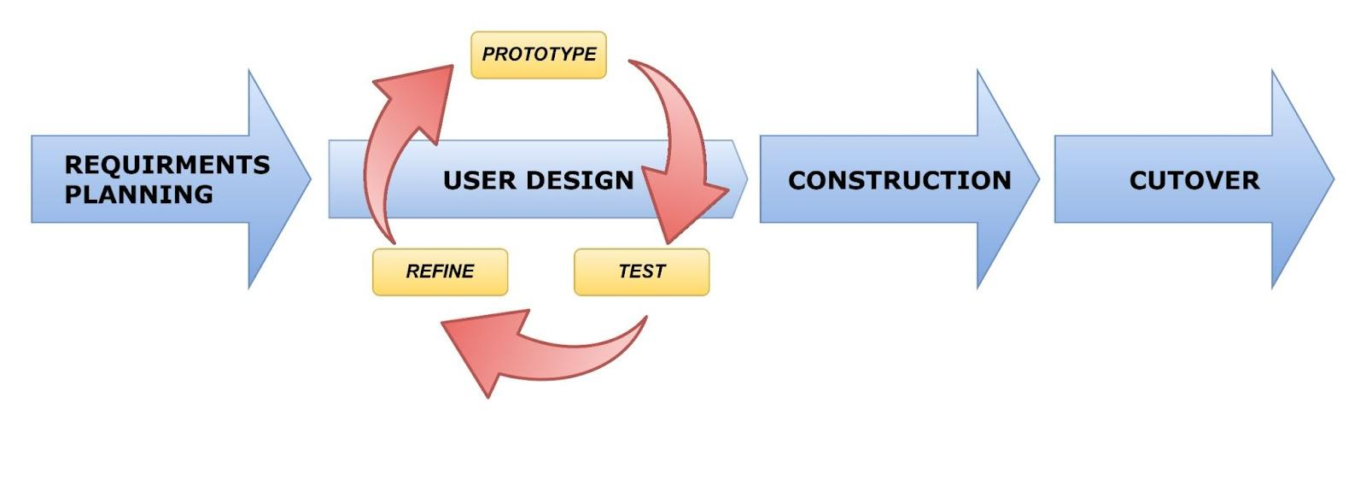

***Figure 4:*** *Rapid Application Development (RAD) Methodology Model*

Rapid Application Development (RAD) approach enables the team to develop software applications quickly and efficiently. The iterative nature of the methodology encourages regular feedback and communication between the team and the client, facilitating a more collaborative and efficient development process. It provides a structured framework for the team to work within, enabling them to focus on delivering high-quality software quickly. The approach emphasizes fast prototyping, which allows the team to identify and address potential issues quickly, ensuring that the software meets the clients' requirements.

The following phases for the study:

* **Requirements planning** - Requirements Planning Phase is a critical stage in the RAD process as it sets the foundation for the project. In this phase, the team focused on gathering and analyzing the requirements of the project, identifying the scope of the application, and determining the feasibility of the project. In this phase, the team adopted a user-centric approach to gather the requirements by conducting interviews with clients, observing end-users, and studying relevant documents.
* **User design -** The team focused on designing the user interface and user experience of the web application, aiming to create an interface that was intuitive, user-friendly, and aligned with the project's goals and requirements. To ensure that the team designed an interface that met the clients' needs, the team will create a prototype of the user interface and test it to gather feedback and make necessary modifications. To balance design aesthetics with functionality, the team adopted an iterative design approach that allows the team to continuously refine the design and functionality of the interface.
* **Construction -** The team focused on implementing the design and functionality of the application, thus beginning to build the entire system using a JavaScript programming language. The development process involved ongoing collaboration and communication with the end-users, who were encouraged to provide feedback and suggestions for improvements throughout the entire process.
* **Cutover -** The team will now focus on deploying the application and ensuring that it was ready for use by the end-users. To ensure a smooth transition from development to production. The team created a deployment plan and tested it in a staging environment. This will allow the team to identify and address any deployment-related issues before releasing the application to the end-users.

**Research Setting**

This research study will take place at Commission on Higher Education (CHED) Regional Office, located on Hayes St, Cagayan de Oro, 9000, Misamis Oriental.

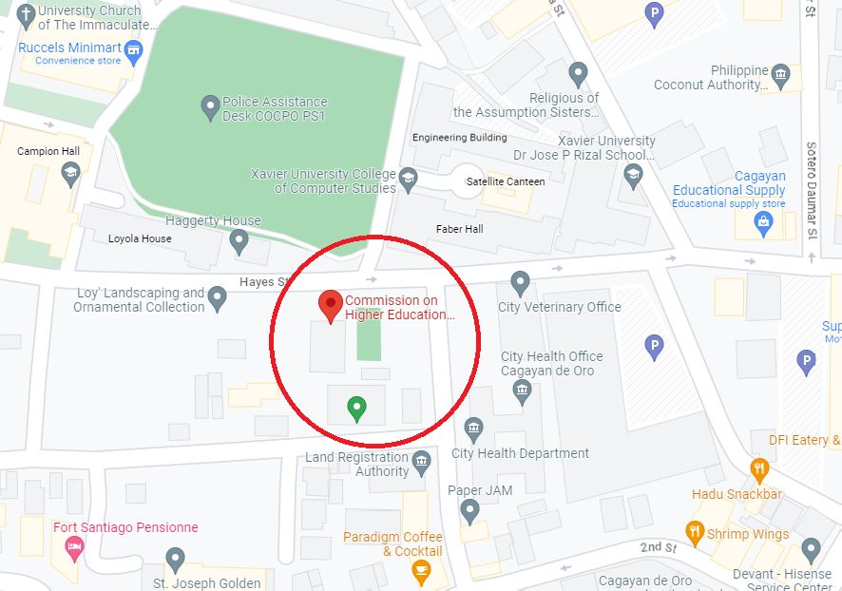



**Research Instruments**

The main source of information for the study was a review of relevant literature. In addition, the researchers also interviewed the individuals in charge of the CHED scholarship program, who provided the necessary documents for the study. The research was conducted using up-to-date hardware and software.

**Data Gathering**

The researchers conducted interviews with individuals who manage the CHED scholarship program to gather information for their study. The researchers discovered that the CHED scholarship program uses a Google Form for applicant registration and retrieves data directly from the database through a query. The management suggested a web application that manages reports, applications, and cuts down processes by half, improving efficiency and reliability. The study will benefit the individuals of CHED Scholarship Program (CSP) and its applicants.

**System Design**

The system design consist of as follows;

**Current System**

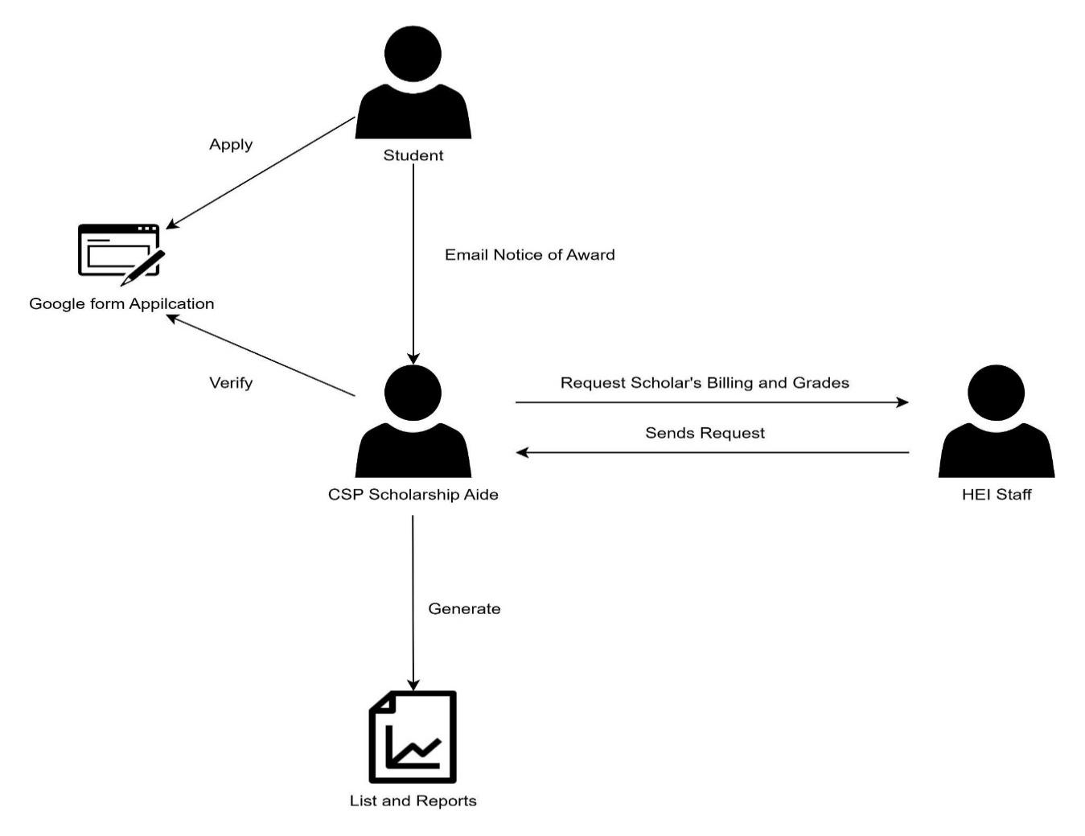

***Figure 5.*** *The Context Diagram of the Current System*

**Narrative Description**

In this figure, CHED scholarship program’s current system has two distinct segments. The first segment pertains to the application process, while the second segment involves billing.

In the application segment, a student who wishes to apply for the CHED scholarship program fills out a Google Form application. The scholarship aide then verifies the student's application form to check the authenticity of the inputs and calculates the equivalent points for scholarship qualification based on the student's grades and annual income. The scholarship aide generates a ranking list of students based on equivalent points and checks for slot availability provided by the Commission on Higher Education’s main office. The scholarship aide then creates a master list sorted based on the ranking list and available slots, which is then stored in their database. The scholarship aide sends an email to the scholar with the Notice of Award and other necessary documents. Finally, the employee manually exports data from the database to a Google spreadsheet with shared access from the Commission on Higher Education central office.

During the billing segment of the CSP scholarship program, the Scholarship Aide responsible for managing the disbursement of funds requests a billing statement and grades from Higher Education Institutions (HEIs) located within Region 10 for the enrolled scholars. Once the request is sent, the respective Higher Education Institution sends back a form that includes the necessary information. The Scholarship Aide then manually reviews and verifies the information provided in the form before generating a report status. After the report status is generated, it is manually encoded into a Google spreadsheet, which is then sent to the liquidation department for the final process of distributing the funds to scholars. However, if a scholar is enrolled in a HEI outside of Region 10, they are required to bring their billing statement and grades to the CHED office. The Scholarship Aide will then coordinate with Scholar to ensure that the necessary steps are taken to process

**Proposed System**

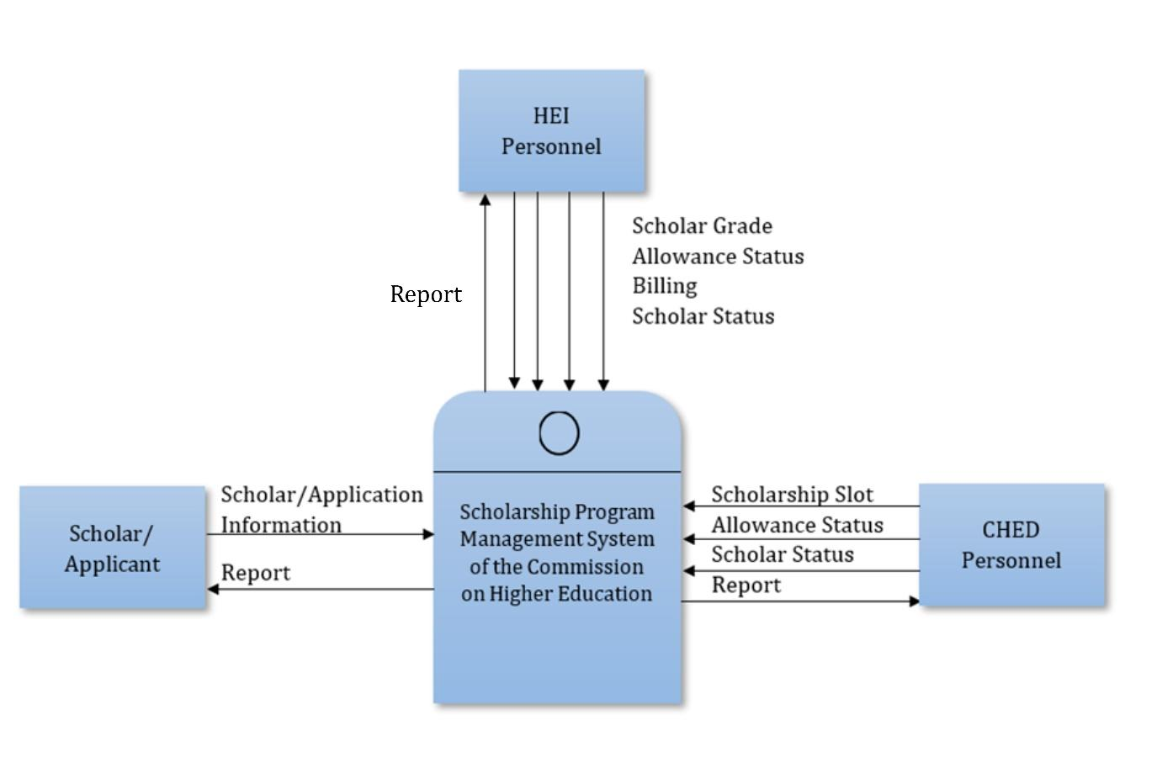

***Figure 6.*** *The Context Diagram of the Proposed System*

**Narrative Description**

The proposed system flow of the Scholarship Program Management System of Commission on Higher Education Region 10 has been enhanced with a dedicated application system, streamlining the application process. This development allows applicants to conveniently submit their scholarship applications through the system, ensuring a seamless and efficient experience. To facilitate effective management and monitoring of the scholarship program, the system provides scholars with access to comprehensive reports on the status of their scholarships and allowances. Through this feature, scholars can conveniently track the progress of their applications and stay informed about any updates or changes pertaining to their scholarship benefits. Within the system, CHED Personnel are entrusted with the crucial responsibility of inputting scholarship slots and managing the Scholarship and Allowance Status of scholars. Furthermore, the system automates the generation of reports, providing CHED Personnel with detailed insights and analytics.

A significant improvement brought about by the enhanced system lies in the seamless integration with HEIs. HEI Personnel are now able to directly transmit billing and grade information of scholars to the system. This newfound efficiency enables CHED Personnel to instantly access the billing and grade details for verification purposes, eliminating the need for tedious back-and-forth communication between CHED and HEIs, thus eliminating delays. Furthermore, HEI Personnel are granted access to update scholars' statuses within the system, fostering improved coordination and communication between institutions. This two-way interaction allows for timely updates on scholars' academic progress and ensures accurate documentation of their performance. Moreover, the system facilitates seamless reporting between HEIs and CHED, empowering HEI Personnel to receive comprehensive reports on the status and performance of their scholars. This valuable data exchange promotes effective collaboration and enables both CHED and HEIs to make informed decisions regarding the scholarship program.

**Entity Relationship Diagram**

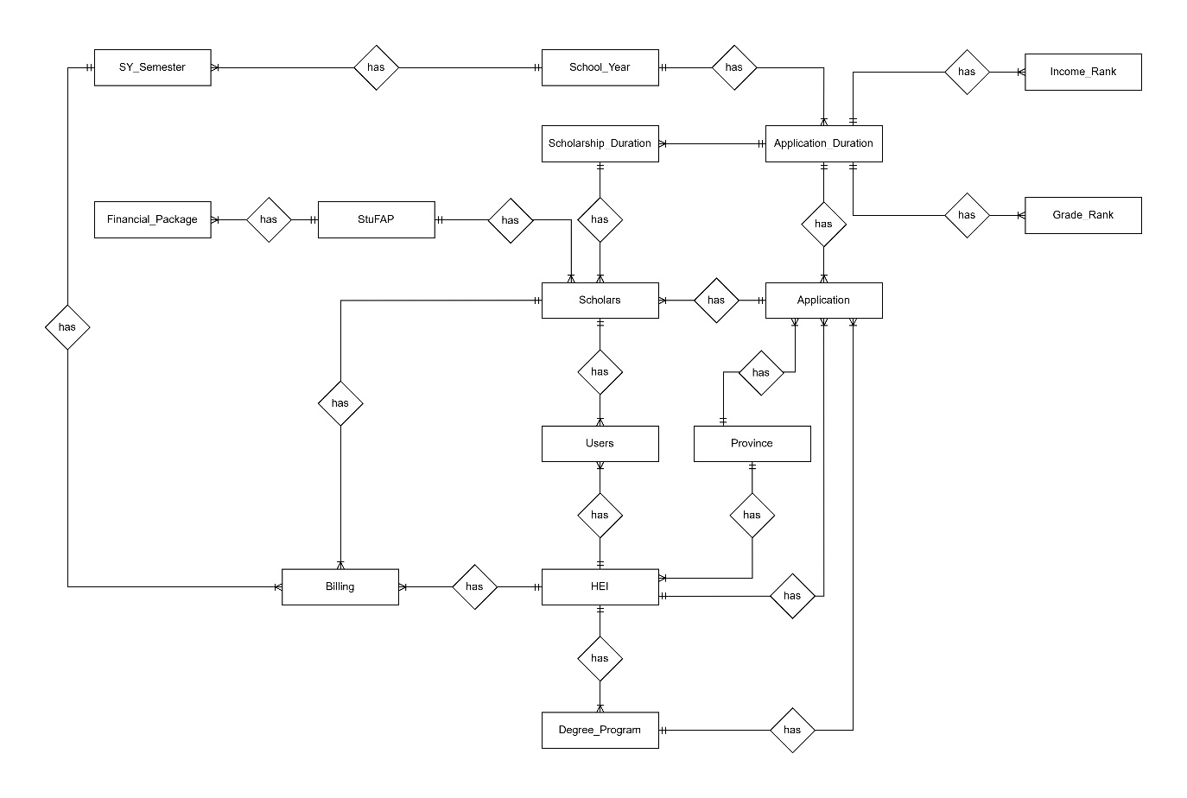

***Figure 7.*** *Entity Relationship Diagram of the CSPMS*

This figure shows the entity relationship diagram of the whole database of Scholarship Program Management System.

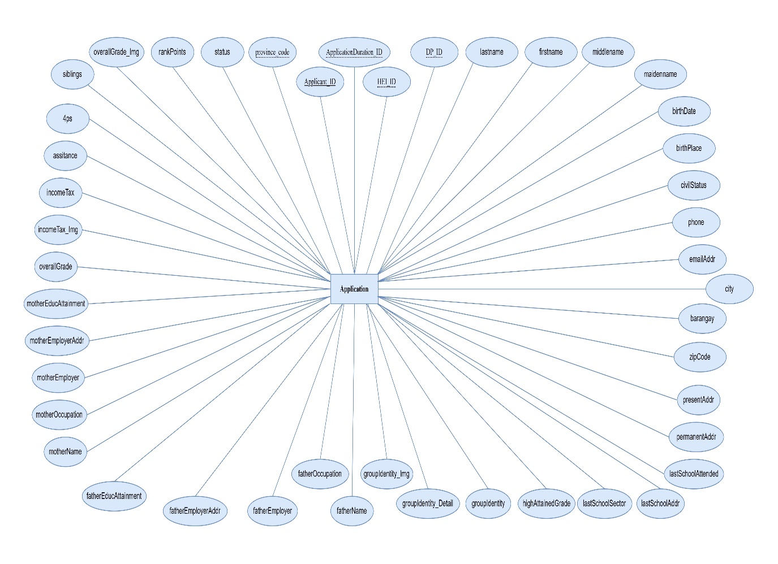

***Figure 8.*** *Application Attributes*

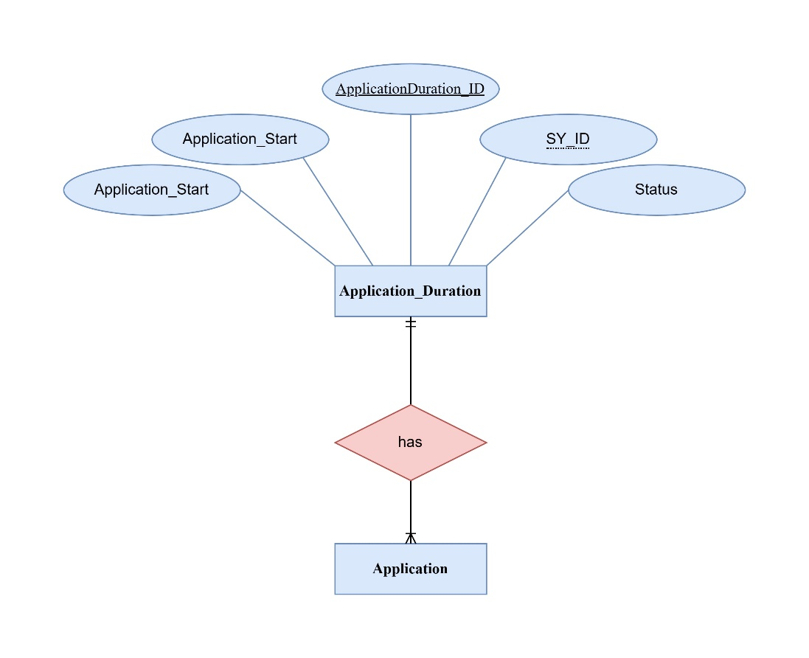

***Figure 9.*** *Application_Duration has one to many Application*

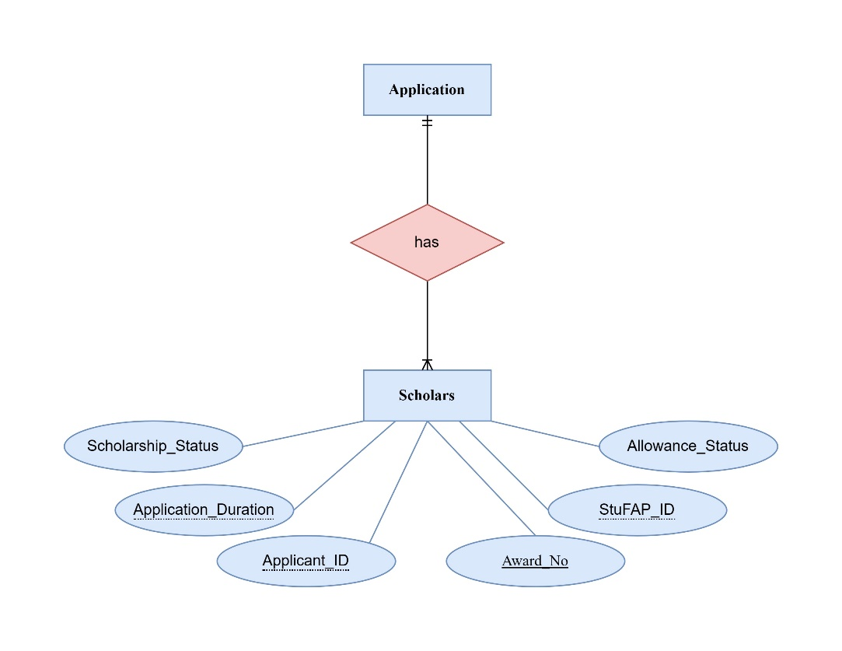

***Figure 10.*** *Application has one to many Scholars*

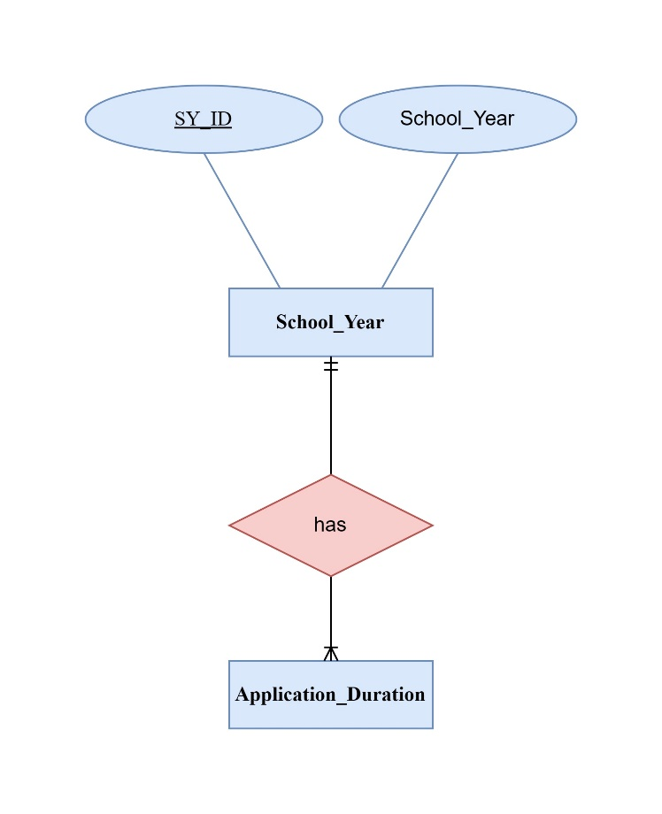

***Figure 11.*** *School_Year has one to many Application_Duration*

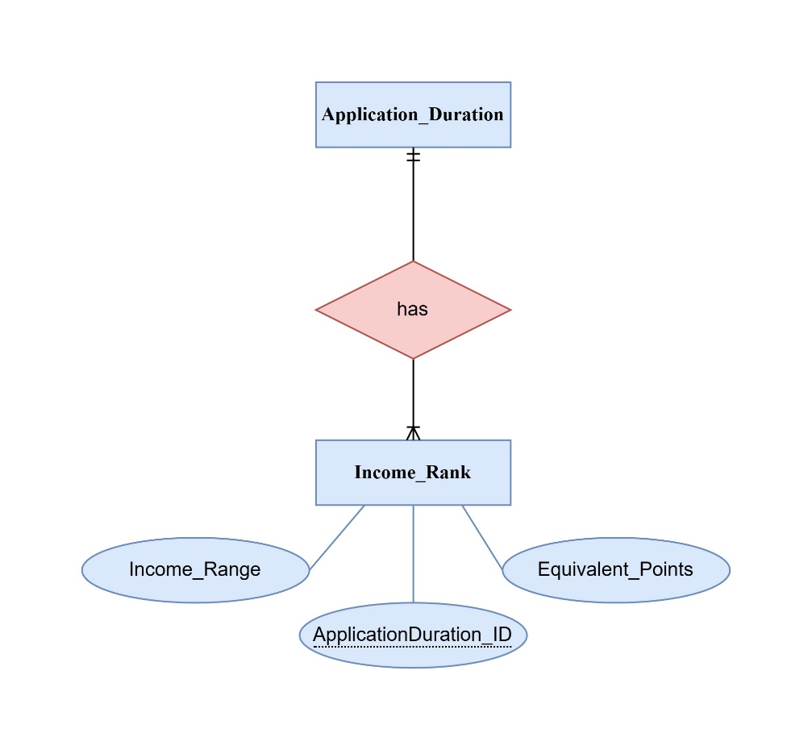

***Figure 12.*** *Application_Duration has one to many Income_Rank*

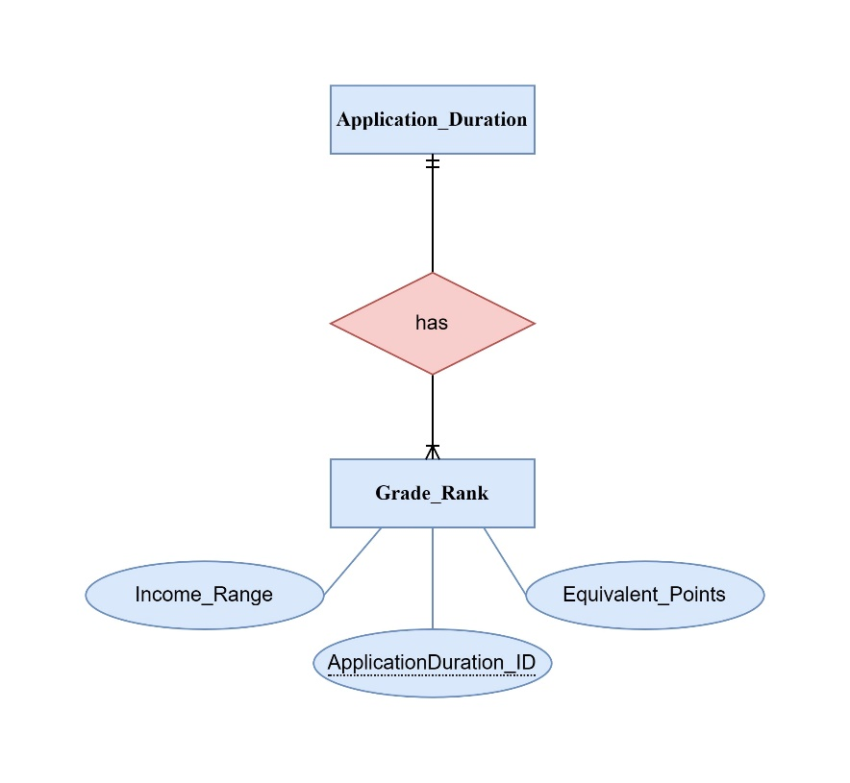

***Figure 13.*** *Application has one to many Grade_Rank*

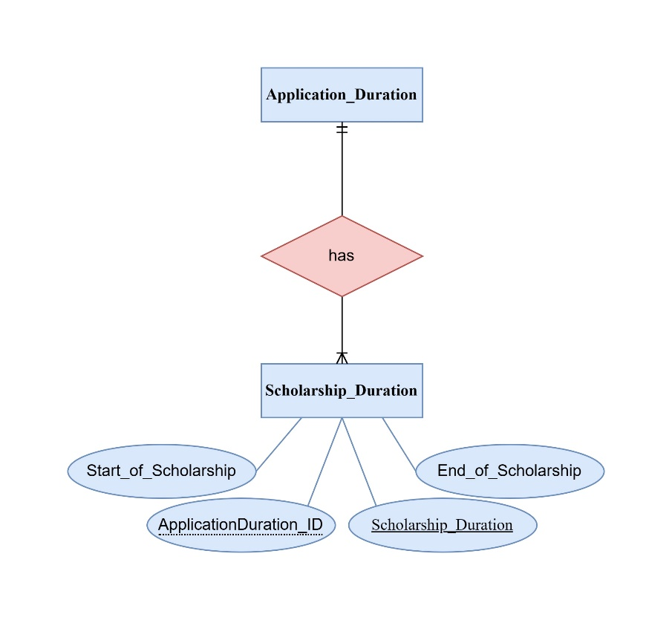

***Figure 14.*** *DegreeProgram has one to many HEI_DP*

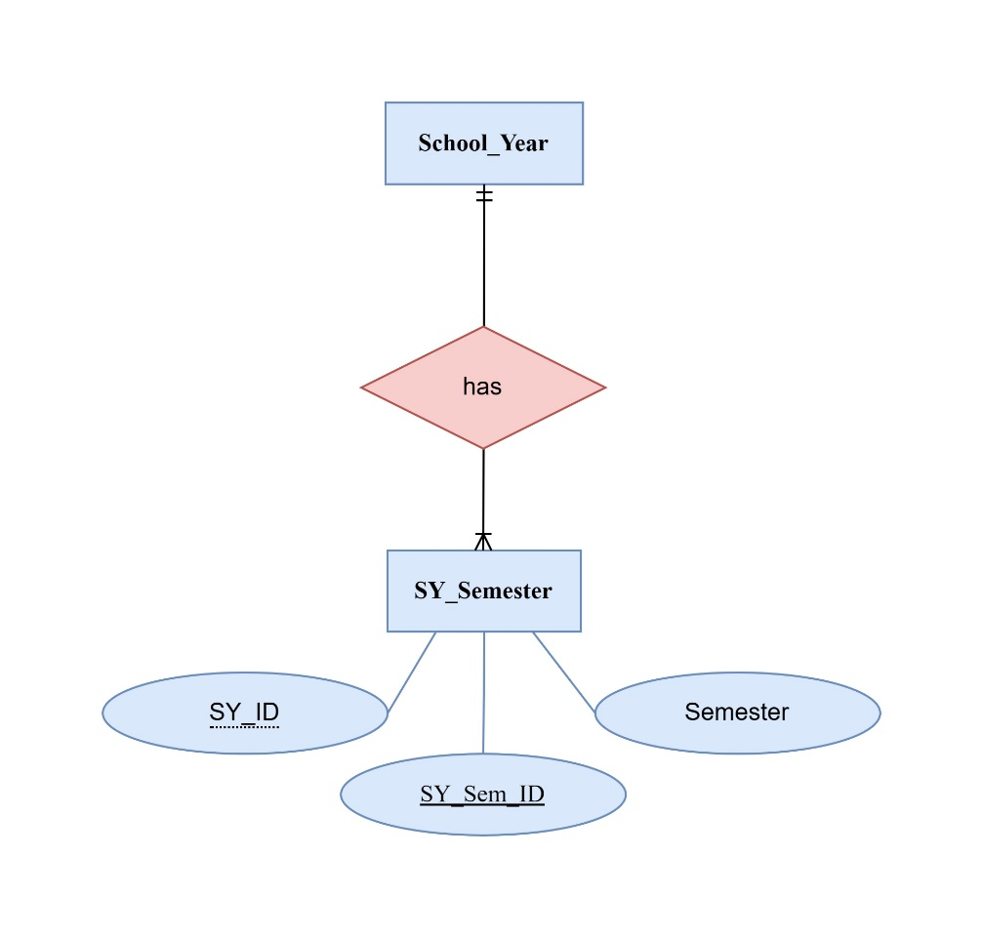

***Figure 15.*** *School_Year has one to many SY_Semester*

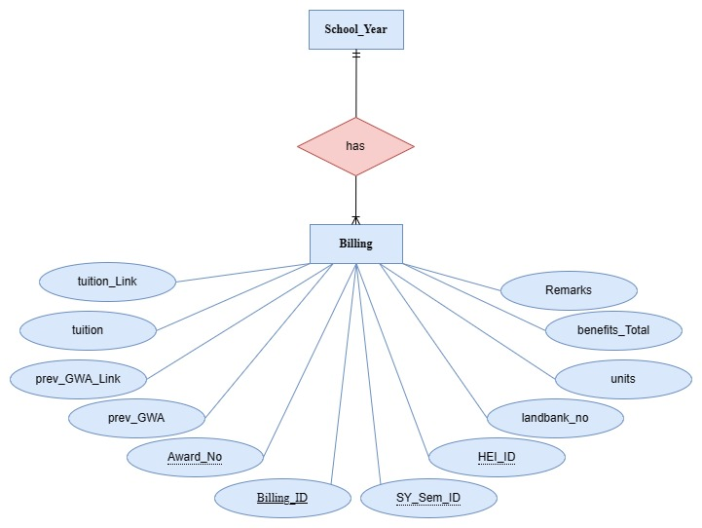

***Figure 16.*** *SY_Semester has one to many Billing*

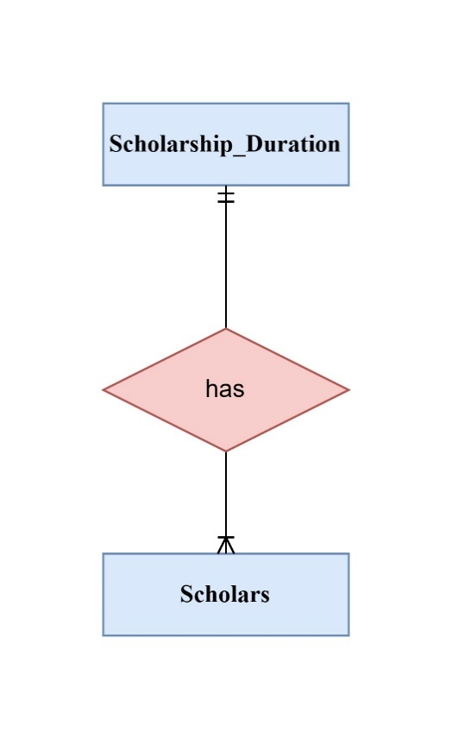

***Figure 17.*** *Scholarship_Duration has one to many Scholars*

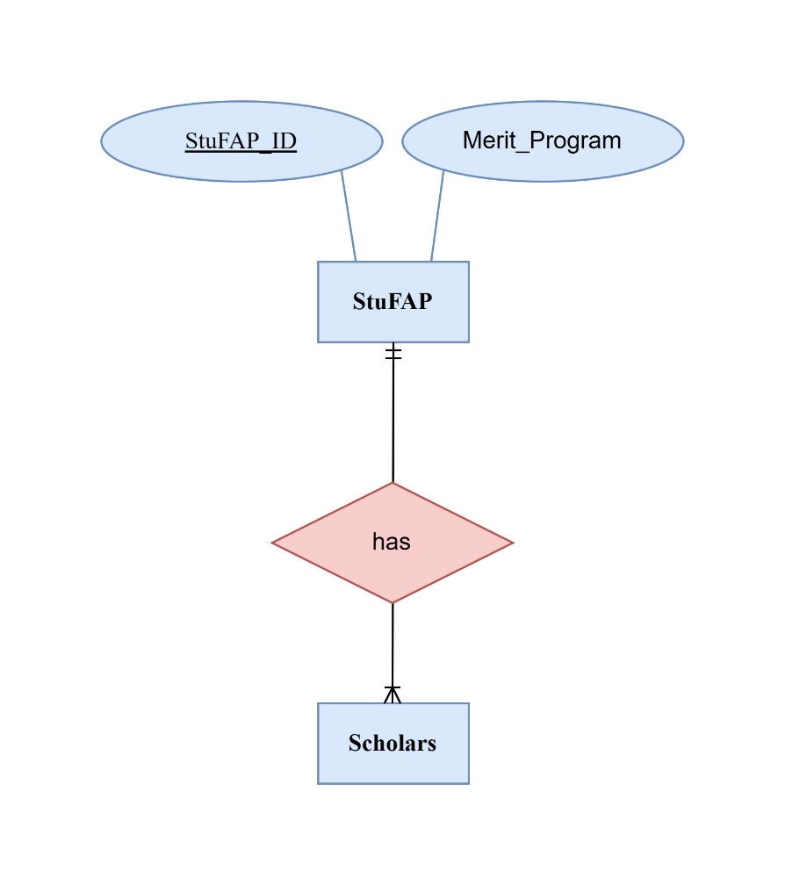

***Figure 18.*** *StuFAP has one to many Scholars*

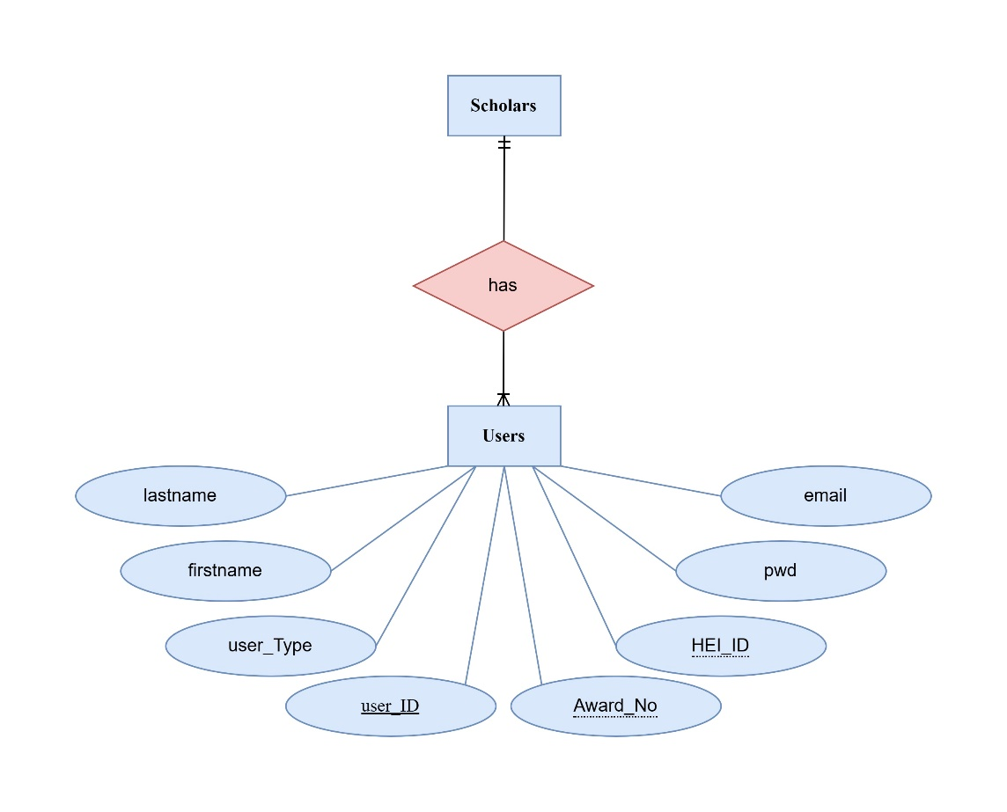

***Figure 19.*** *Scholars has one to many Users*

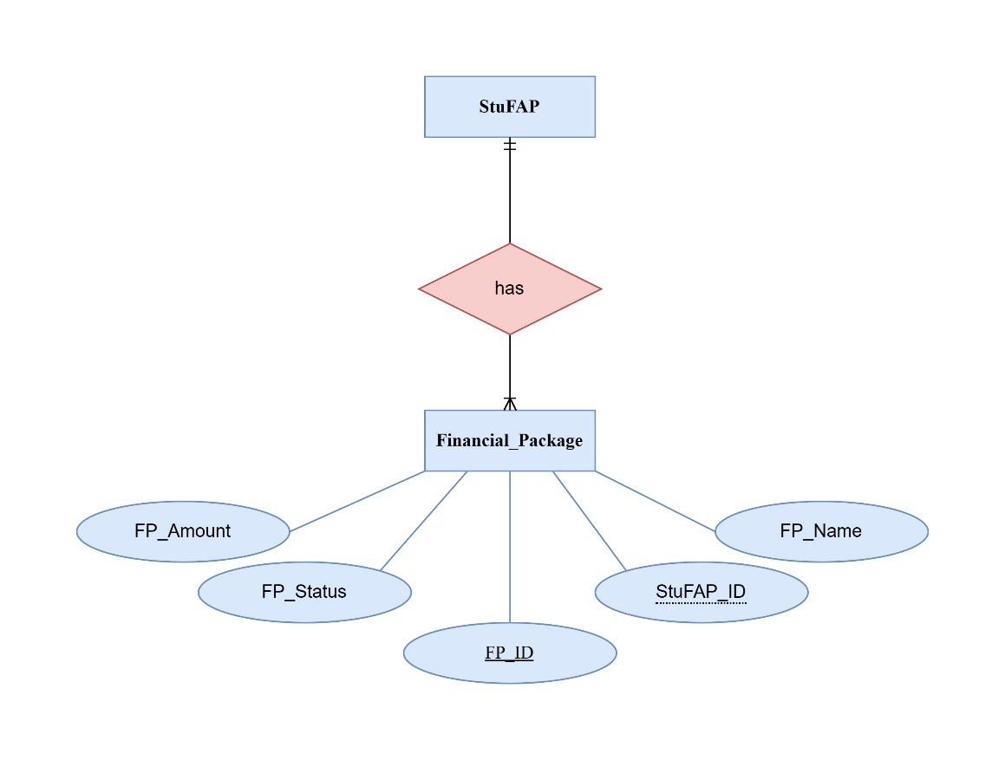

***Figure 20.*** *StuFAP has one to many Financial_Package*

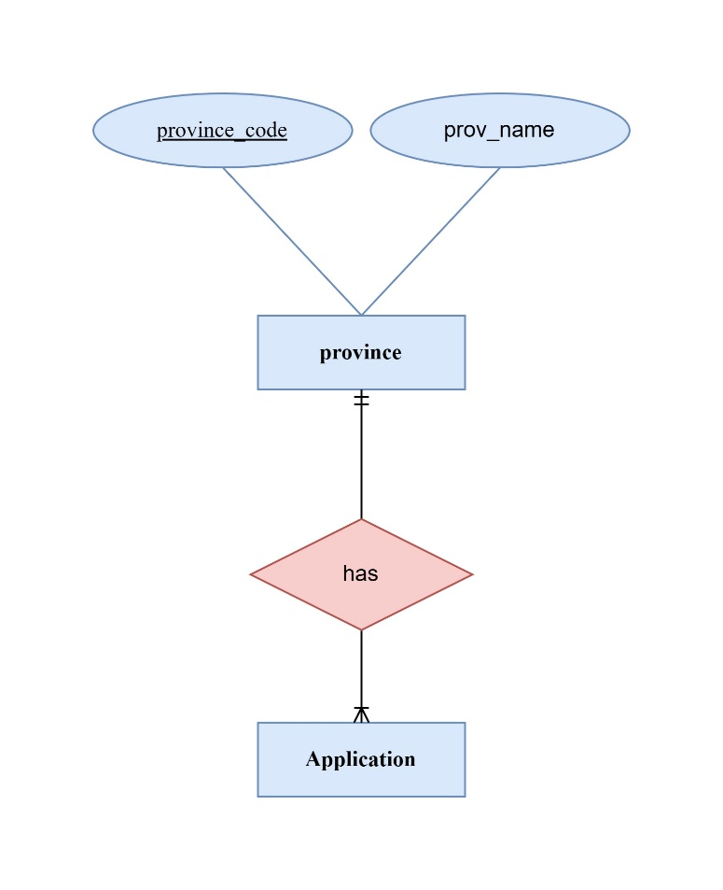

***Figure 21.*** *province has one to many Application*

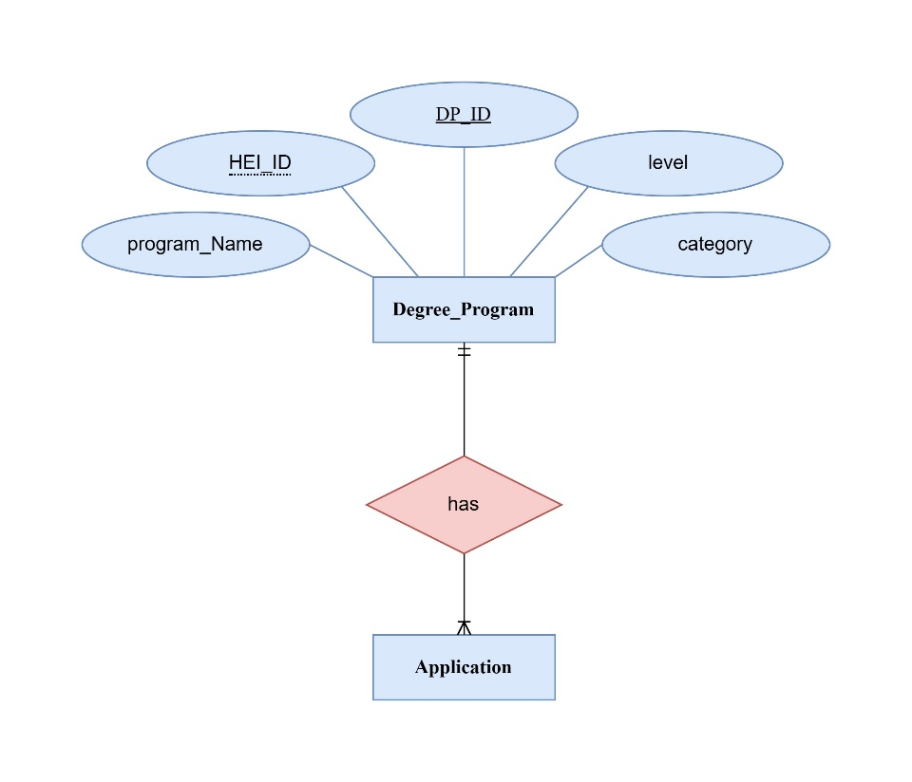

***Figure 22.*** *Degree_Program has one to many Application*

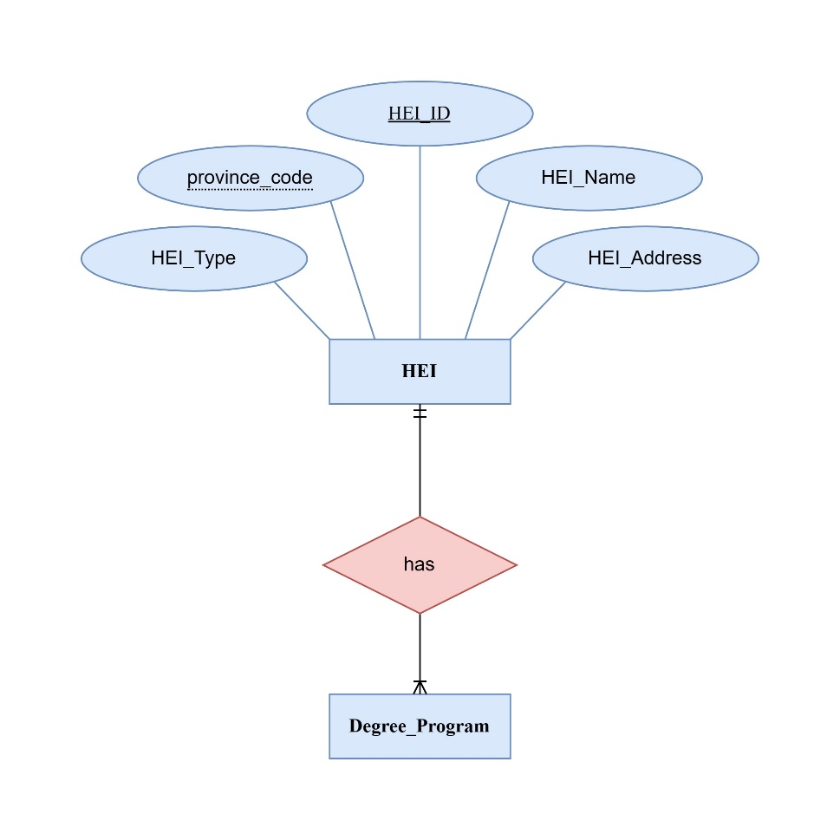

***Figure 23.*** *HEI has one to many Degree_Program*

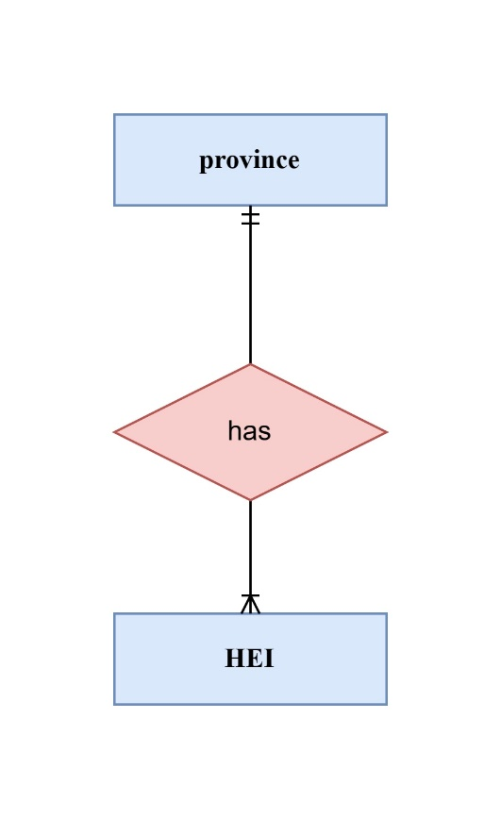

***Figure 24.*** *province has one to many HEI*

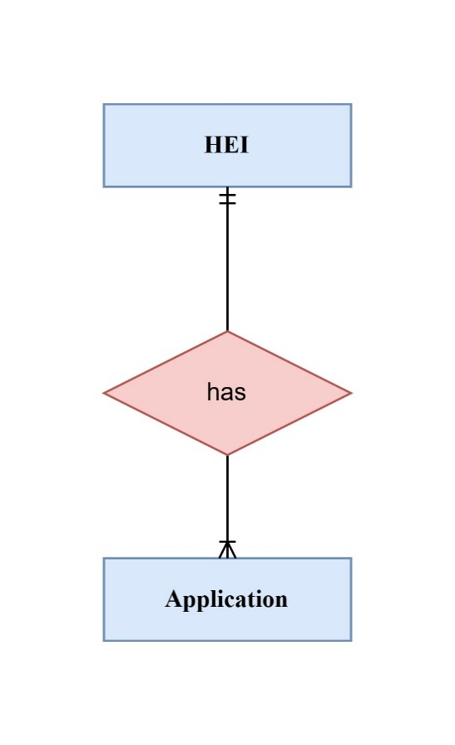

***Figure 25.*** *HEI has one to many Application*

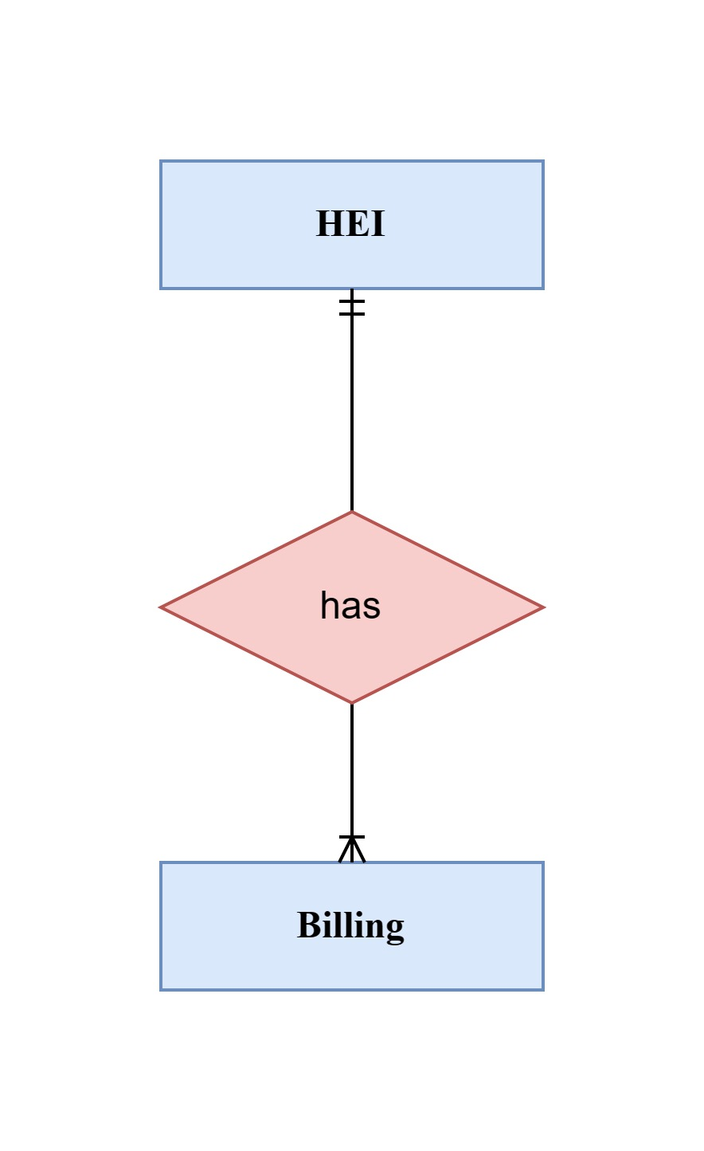

***Figure 26.*** *HEI has many to one Billing*

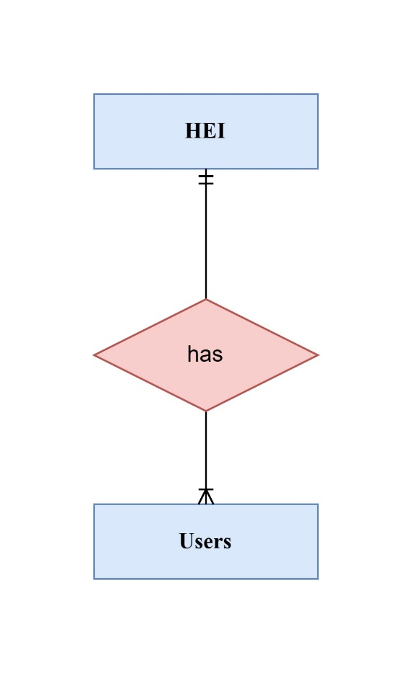

***Figure 27.*** *HEI has one to many Users*

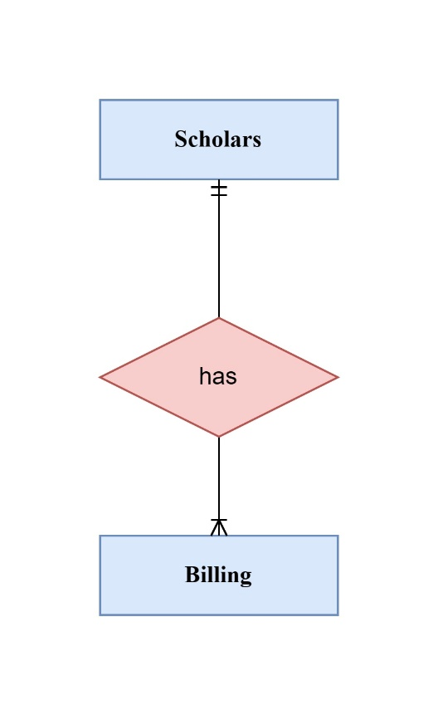

***Figure 28.*** *Scholars has one to many Billing*

**Database Structure**

The database contains 15 entities or tables, each with its unique set of data attributes.

|  |  |  |  |
| --- | --- | --- | --- |
| **Entity Name** | **No of Attributes** | **Primary Key** | **No. of Foreign Key** |
| Application | 48 | ✔ | 4 |
| Application_Duration | 5 | ✔ | 1 |
| School_Year | 2 | ✔ |  |
| Province | 2 | ✔ |  |
| SY_Semester | 3 | ✔ | 1 |
| Financial_Packange | 6 | ✔ | 1 |
| Degree_Program | 5 | ✔ | 1 |
| Scholars | 6 | ✔ | 2 |
| HEI | 5 | ✔ | 1 |
| Scholarship_Duration | 4 | ✔ | 1 |
| StuFAP | 2 | ✔ |  |
| Billing | 12 | ✔ | 3 |
| Grade_Rank | 3 |  | 1 |
| Income_Rank | 3 |  | 1 |
| Users | 9 | ✔ | 3 |

The relationships depicted in the diagram are all one-to-many

**Data Dictionary**

**Table 1. Application**

|  |  |  |  |  |
| --- | --- | --- | --- | --- |
| Filename | Type | Size | Value | Description |
| Applicant_ID | Integer | 6 | Not Null | PK-Applicant ID |
| ApplicationDuration_ID | Integer | 6 | Not Null | FK-Application ID |
| DP_ID | Integer | 6 | Not Null | FK-HEI_DP ID |
| HEI_ID | Varchar | 10 | Not Null | FK-HEI_ID |
| province_code | Integer | 6 | Not Null | FK-province_code |
| firstname | Varchar | 25 | Not Null | Applicant First Name |
| lastname | Varchar | 25 | Not Null | Applicant Last Name |
| middlename | Varchar | 25 | Not Null | Applicant Middle Name |
| Maidenname | Varchar | 25 | Not Null | Applicant Maiden Name |
| birthDate | Date |  | Not Null | Applicant Date of Birth |
| birthplace | Varchar | 25 | Not Null | Applicant Place of Birth |
| Sex | Integer | 1 | Not Null | e.g. 1-Male, 2-Female |
| civilStatus | Integer | 1 | Not Null | e.g. 1-Single, 2-Married |
| phone | Integer | 11 | Not Null | Applicant Mobile No. |
| emailAddr | Varchar | 25 | Not Null | Applicant Emaill Address |
| city | Integer | 1 | Not Null | e.g. 1- CDOC, 2-Iligan City |
| barangay | Integer | 1 | Not Null | e.g. 1-Macabalan, 2-Carmen |
| zipCode | Integer | 4 | Not Null | e.g. 9000, 9014 |
| presentAddr | Varchar | 25 | Not Null | Present Address |
| permanentAddr | Varchar | 25 | Not Null | Permanent Address |
| lastSchoolAttended | Varchar | 25 | Not Null | School Last Attended |
| lastSchoolAddr | Varchar | 25 | Not Null | School Address |
| lastSchoolSector | Integer | 1 | Not Null | e.g. 1-Private, 0-Public |
| highAttainedGrade | Varchar | 25 | Not Null | Highest Attained Grade |
| groupIdentity | Integer | 1 | Not Null | e.g. 1-PWD, 2-IP |
| groupIdentity_Detail | Varchar | 25 | Not Null | Identity Detail |
| groupIdentity_Img | BLOB |  | Not Null | Identity Proof |
| fatherName | Varchar | 25 | Not Null | Applicant Father Name |
| fatherOccupation | Varchar | 25 | Not Null | Father Occupation |
| fatherEmployer | Varchar | 25 | Not Null | Employer Name |
| fatherEmployerAddr | Varchar | 25 | Not Null | Employer Address |
| fatherEducAttainment | Varchar | 25 | Not Null | Educational Attainment |
| motherName | Varchar | 25 | Not Null | Applicant Mother Name |
| motherOccupation | Varchar | 25 | Not Null | Mother Occupation |
| motherEmployer | Varchar | 25 | Not Null | Employer Name |
| motherEmployerAddr | Varchar | 25 | Not Null | Employer Address |
| motherEducAttainment | Varchar | 25 | Not Null | Educational Attainment |
| Total_Parents_Taxable_Income | Double | 6, 2 | Not Null | Total Parents Income |
| sibilings | Integer | 1 | Not Null | Number of Siblings |
| 4ps | Integer | 1 | Not Null | e.g. 1-Yes, 2-No |
| assistance | Integer | 1 | Not Null | e.g.g 1-Yes, 2-No |
| incomeTax | Double | 6, 2 | Not Null | Income Tax |
| incomeTax_Img | BLOB |  | Not Null | Income Tax Proof |
| overallGrade | Varchar | 3 | Not Null | Overall Grade |
| rankPoints | Integer | 3 | Not Null | Rank Points |
| status | Integer | 1 | Not Null | e.g. 1-Active, 2-Inactive |

*Table 1. Contains Application Information*

**Table 2. Application_Duration**

|  |  |  |  |  |
| --- | --- | --- | --- | --- |
| **Filename** | **Type** | **Size** | **Value** | **Description** |
| ApplicationDuration_ID | Integer | 6 | Not Null | PK – ApplicationDuration ID |
| SY_ID | Integer | 6 | Not Null | FK – SY_ID |
| Application_Start | Date |  | Not Null | Application Start |
| Application_End | Date |  | Not Null | Application End |
| Status | Integer | 1 | Not Null | e.g. 1-Open 2- Close |

*Table 2. Contains Application_Duration*

**Table 3. Billing**

|  |  |  |  |  |
| --- | --- | --- | --- | --- |
| Filename | Type | Size | Value | Description |
| Billing_ID | Integer | 6 | Not Null | PK-Billing_ID |
| SY_Sem_ID | Integer | 6 | Not Null | FK-SY_Sem_ID |
| Award_No | Varchar | 10 | Not Null | FK-Award_No |
| HEI_ID | Integer | 6 | Not Null | FK-HEI_ID |
| prev_GWA | Varchar | 3 | Not Null | Previous GWA |
| prev_GWA_Link | Text |  | Not Null | Previous GWA Link |
| units | Integer | 2 | Not Null | Units |
| tuition | Double | 5, 2 | Not Null | Tuition |
| tuition_Link | Text | 5, 2 | Not Null | Tuition Link |
| landbank_no | Varchar | 25 | Not Null | Landbank Number |
| benefits_Total | Double | 6, 2 | Not Null | Total Benefits |
| Remarks | Integer | 1 | Not Null | e.g. 1-Pass, 2-Failed |

*Table 3. Contains Billing Information*

**Table 4. Degree_Program**

|  |  |  |  |  |
| --- | --- | --- | --- | --- |
| **Filename** | **Type** | **Size** | **Value** | **Description** |
| DP_ID | Integer | 6 | Not Null | PK-DP_ID |
| HEI_ID | Varchar | 10 | Not Null | FK-HEI_ID |
| programName | Varchar | 50 | Not Null | e.g. BSIT |
| level | Varchar | 50 | Not Null | e.g. Doctoral |
| category | Varchar | 50 | Not Null | e.g. IT Related |

*Table 4. Contains Degree_Program Information*

**Table 5. Financial_Package**

|  |  |  |  |  |
| --- | --- | --- | --- | --- |
| **Filename** | **Type** | **Size** | **Value** | **Description** |
| FP_ID | Varchar | 15 | Not Null | PK-FP_ID |
| StuFAP_ID | Varchar | 10 | Not Null | FK-StuFAP_ID |
| Period | Varchar | 10 | Not Null | e.g. Annual, Semestral |
| FP_Name | Varchar | 15 | Not Null | e.g. TOSF, Stipend |
| FP_Amount | Double | 7, 2 | Not Null | FP Amount |
| FP_Status | Integer | 1 | Not Null | e.g. 1-Active. 2-Inactive |

*Table 5. Contains Financial_Package Information*

**Table 6. Grade_Rank**

|  |  |  |  |  |
| --- | --- | --- | --- | --- |
| Filename | Type | Size | Value | Description |
| ApplicationDuration_ID | Integer | 6 | Not Null | FK-ApplicationDuration_ID |
| Grade_Range | Varchar | 5 | Not Null | Grade Range |
| Equivalent_Points | Integer | 3 | Not Null | Equivalent Points |

*Table 6. Contains Grade_Rank Information*

**Table 7. HEI**

|  |  |  |  |  |
| --- | --- | --- | --- | --- |
| Filename | Type | Size | Value | Description |
| HEI_ID | Varchar | 10 | Not Null | PK-HEI ID |
| province_code | Integer | 6 | Not Null | FK-province_code |
| HEI_Name | Varchar | 80 | Not Null | HEI Name |
| HEI_Address | Varchar | 80 | Not Null | HEI Address |
| HEI_Type | Varchar | 5 | Null | e.g. PHEI, LUC, SUC |

*Table 7. Contains the Information of Higher Education Institute*

**Table 8. Income_Rank**

|  |  |  |  |  |
| --- | --- | --- | --- | --- |
| Filename | Type | Size | Value | Description |
| ApplicationDuration_ID | Integer | 6 | Not Null | FK-ApplicationDuration_ID |
| Income_Range | Varchar | 5 | Not Null | Income Range |
| Equivalent_Points | Integer | 3 | Not Null | Equivalent Points |

*Table 8. Contains Income_Rank Information*

**Table 9. Scholars**

|  |  |  |  |  |
| --- | --- | --- | --- | --- |
| Filename | Type | Size | Value | Description |
| Award_No | Varchar | 20 | Not Null | PK-Award_No |
| Applicant_ID | Integer | 6 | Not Null | FK-Applicant ID |
| StuFAP_ID | Integer | 6 | Not Null | FK-StuFAP_ID |
| ScholarshipDuration_ID | Integer | 6 | Not Null | FK-ScholarshipDuration ID |
| Allowance_Status | Integer | 1 | Not Null | 1-Released, 2-Processing |
| Scholarship_Status | Integer | 1 | Not Null | 1-Active, 2-Inactive |

*Table 9. Contains Scholars Information*

**Table 10. Province**

|  |  |  |  |  |
| --- | --- | --- | --- | --- |
| Filename | Type | Size | Value | Description |
| province_code | Integer | 10 | Not Null | PK-Province_Code |
| prov_name | Varchar | 25 | Not Null | e.g. Misamis Oriental |

*Table 10. Contains Province Information*

**Table 11. Scholarship_Duration**

|  |  |  |  |  |
| --- | --- | --- | --- | --- |
| Filename | Type | Size | Value | Description |
| ScholarshipDuration_ID | Integer | 6 | Not Null | PK-ScholarshipDuration_ID |
| ApplicationDuration_ID | Integer | 6 | Not Null | FK-ApplicationDuration_ID |
| Start_of_Scholarship | Date |  | Not Null | Start of Scholarship |
| End_of_Scholarship | Date |  | Not Null | End of Scholarship |

*Table 11. Contains Scholarship_Duration*

**Table 12. School_Year**

|  |  |  |  |  |
| --- | --- | --- | --- | --- |
| Filename | Type | Size | Value | Description |
| SY_ID | Integer | 11 | Not Null | PK-SY_ID |
| School_Year | Integer | 9 | Not Null | e.g. 2023-2024 |

*Table 11. Contains School_Year*

**Table 13. StuFAP**

|  |  |  |  |  |
| --- | --- | --- | --- | --- |
| Filename | Type | Size | Value | Description |
| StuFAP_ID | Varchar | 10 | Not Null | PK-StuFAP_ID |
| Merit_Program | Varchar | 15 | Not Null | e.g. Full PESFA, Half PESFA |

*Table 12. Contains StuFAP Information*

**Table 14. SY_Semester**

|  |  |  |  |  |
| --- | --- | --- | --- | --- |
| Filename | Type | Size | Value | Description |
| SY_Sem_ID | Integer | 6 | Not Null | PK-SY_Sem_ID |
| SY_ID | Varchar | 11 | Not Null | FK-SY_ID |
| Semester | Varchar | 12 | Not Null | e.g. 1st Semester, 2nd Semester |

*Table 13. Contains the Duration of Scholarship*

**Table 15. Users**

| Filename | Type | Size | Value | Description |
| --- | --- | --- | --- | --- |
| User_ID | Integer | 6 | Not Null | PK-User_ID |
| Award_No | Varchar | 20 | Not Null | FK-Award_No |
| HEI_ID | Integer | 6 | Not Null | FK-HEI ID |
| firstname | Varchar | 20 | Not Null | User First Name |
| lastname | Varchar | 20 | Not Null | User Last Name |
| email | Varchar | 20 | Not Null | User Email |
| pwd | Varchar | 16 | Not Null | User Password |
| user_Type | Integer | 1 | Not Null | e.g. 1-Admin, 2-User |

*Table 15. Contains Users Information*

**Use Case Diagram**

**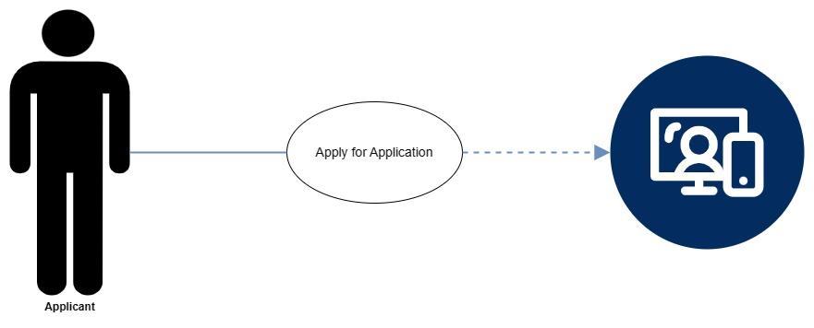*Figure 29.*** *The Case Diagram for Applicant*

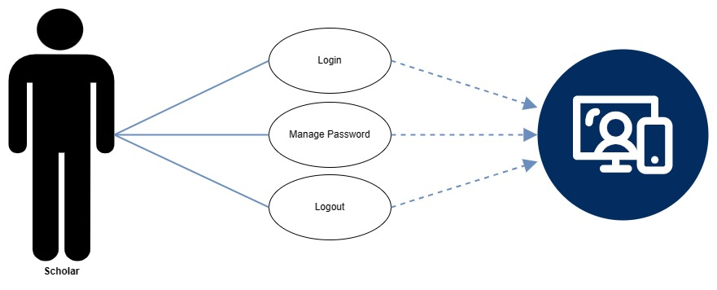

***Figure 30.*** *The Case Diagram for Scholar*

**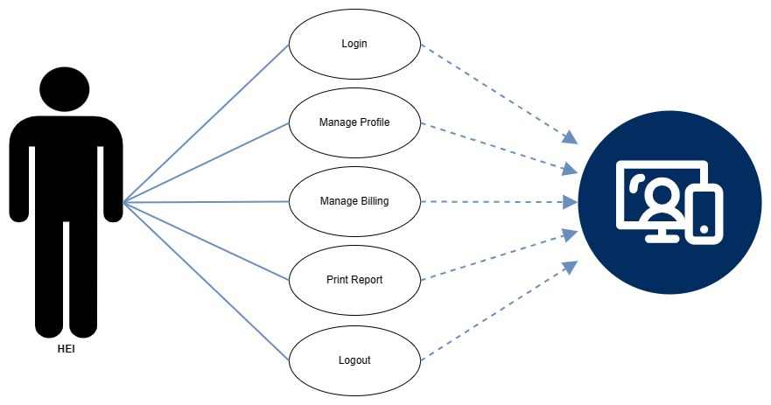*Figure 31.*** *The Case Diagram for HEI Personnel*

**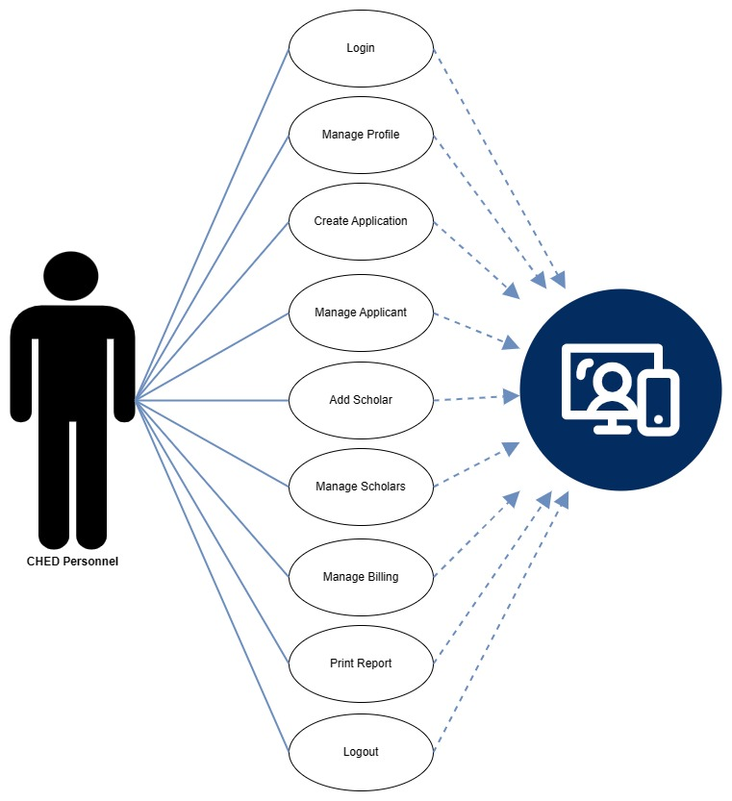*Figure 32.*** *The Case Diagram for CHED Personnel*

**Use Case Description**

|  |  |
| --- | --- |
| **Actor:** | **Applicant** |
| Use Case Name: | Application |
| Description: | The use case explains how the Applicant apply for the CHED Scholarship Program. |
| Normal Flow: | The user must input/ upload the scholarship application requirements, including personal information, family background, general weighted average, and parents’ annual income, as well as necessary attachments. And submit their scholarship application requirements to the web application. |
| Alternate Flow: | If the applicant neglects to complete the required information, the application will be considered unsuccessful. |
| Preconditions: | The applicant must have an access in the scholarship management system. |
| Postconditions: | The applicant’s scholarship application submitted successfully. |
| Assumption: | The applicant's scholarship application requirements are stored in the system for review. |

***Table 16.*** *Use case description for Applicant*

|  |  |
| --- | --- |
| **Actor:** | **Scholar** |
| Use Case Name: | Login |
| Description: | The use case explains how the Scholar access the Scholarship Program Management System. |
| Normal Flow: | 1. The scholar is in the login page 2. The scholar enters their login credentials. 3. The system validates the scholar’s password and logs the scholar into the system. 4. The system displays the scholar’s page. 5. The use case ends. |
| Alternate Flow: | If the login scholar_ID and Password are invalid, the scholar has to re-enter as valid scholar_ID or Password given from CHED. |
| Preconditions: | The system must be connected to the network. |
| Postconditions: | The scholar logs in successfully. |
| Assumption: | The scholar is registered to the database. |

***Table 16.*** *Use case description for Scholar Login*

|  |  |
| --- | --- |
| **Actor:** | **Scholar** |
| Use Case Name: | Manage Password |
| Description: | The use case allows the Scholar to update/change the password in the system. |
| Normal Flow: | 1. The system displays the Scholars Information. 2. The scholar changes their password of the desired personal password. 3. The system validates. 4. The use case ends. |
| Alternate Flow: | Change Password |
| Preconditions: | The scholar must log into the system. |
| Postconditions: | The scholar password changed successfully. |
| Assumption: | The system notifies the scholar that the password successfully changed. |

***Table 17.*** *Use case description for Scholar Manage Password.*

|  |  |
| --- | --- |
| **Actor:** | **Scholar** |
| Use Case Name: | Logout |
| Description: | The use case explains the process of a scholar logging out of the system. Following the logout action, the scholar session is promptly terminated. |
| Normal Flow: | 1. The scholar concludes their tasks within the application. 2. The scholar clicks the logout button. 3. The system performs a secure logout, invalidating the user session. 4. The use case ends. |
| Alternate Flow: | *N/A* |
| Preconditions: | The scholar must log into the system. |
| Postconditions: | The scholar is successfully logged out. |
| Assumption: | The scholar is registered to the database. |

***Table 18.*** *Use case description for Scholar Logout.*

|  |  |
| --- | --- |
| **Actor:** | **HEI Personnel** |
| Use Case Name: | Login |
| Description: | The use case explains how the HEI Personnel access the Scholarship Program Management System. |
| Normal Flow: | 1. The HEI Personnel is in the login page 2. The scholar enters their login credentials. 3. The system validates the HEI Personnel password and logs the scholar into the system. 4. The system displays the HEI page. 5. The use case ends. |
| Alternate Flow: | If the login HEI_ID and Password are invalid, the scholar has to re-enter as valid HEI_ID or Password given from CHED. |
| Preconditions: | The system must be connected to the network. |
| Postconditions: | The HEI logs in successfully. |
| Assumption: | The HEI Personnel is registered to the database. |

***Table 19.*** *Use case description for HEI Personnel Login*

|  |  |
| --- | --- |
| **Actor:** | **HEI Personnel** |
| Use Case Name: | Manage Profile |
| Description: | The use case allows the HEI Personnel to edit/update the HEI Account Information Profile in the system. |
| Normal Flow: | 1. The system displays the HEI Personnel Account Information profile. 2. The HEI Personnel can seamlessly edit and update the desired personal information, ensuring accuracy and relevance. 3. The system validates the entered HEI Personnel Account Information Profile will be fully updated. 4. The use case ends. |
| Alternate Flow: | Edit/Update Profile. |
| Preconditions: | The HEI Personnel must log into the system. |
| Postconditions: | The HEI Personnel is successfully updated. |
| Assumption: | The system notifies that the HEI Personnel account information is updated. |

***Table 20.*** *Use case description for HEI Personnel Manage Profile.*

|  |  |
| --- | --- |
| **Actor:** | **HEI Personnel** |
| Use Case Name: | Manage Billing |
| Description: | The use case outlines the process of managing billing information for scholars within a system. It involves searching for a scholar account, displaying the account details, uploading necessary documents, and confirming the successful update of document. |
| Normal Flow: | 1. The system prompts the HEI Personnel to manage billing information for a scholar. 2. The HEI Personnel selects the option to search for a scholar account. 3. The system provides a search interface, and the HEI Personnel enters the necessary scholar details. 4. The system retrieves and displays the scholar account information. 5. The HEI Personnel uploads the required documents. 6. The system verifies and process the upload documents. 7. The system displays a confirmation message indicating that the documents have been successfully updated. |
| Alternate Flow: | If the scholar is account is not found during the search; The system informs the HEI Personnel that the scholar account does not exist. The HEI Personnel is prompted to re-enter the scholar details. |
| Preconditions: | The HEI Personnel is authenticated and has the necessary permissions to manage billing for scholars. The scholar account exists in the system. |
| Postconditions: | The scholar’s billing information is successfully updated. The system displays a confirmation message indicating the successful update of documents. |
| Assumption: | The HEI Personnel have the required knowledge and access rights to manage billing information. The documents upload process includes validation checks for the document format and completeness, |

***Table 21.*** *Use case description for HEI Personnel Manage Billing.*

|  |  |
| --- | --- |
| **Actor:** | **HEI Personnel** |
| Use Case Name: | Print Report |
| Description: | The use case outlines the process of HEI Personnel printing reports within a system. |
| Normal Flow: | 1. The HEI Personnel initiate the process to print reports. 2. The system provides an interface with options to select the type of reports to be printed. 3. The reports are printed, and the system displays a confirmation message. |
| Alternate Flow: | If there is an issue with the process (e.g., connection issues); The HEI Personnel may troubleshoot the issue. |
| Preconditions: | The HEI Personnel is authenticated and has the necessary permissions to access and printed reports. The reports to be printed are available and up-to-date in the system. |
| Postconditions: | The selected reports are successfully printed and available. |
| Assumption: | The reports generated are accurate and reflect the current state of the system. |

***Table 22.*** *Use case description for HEI Personnel Print Report.*

|  |  |
| --- | --- |
| **Actor:** | **HEI Personnel** |
| Use Case Name: | Logout |
| Description: | The use case outlines the process of HEI Personnel logging out of a system. |
| Normal Flow: | 1. The HEI Personnel initiate the logout process. 2. The system confirms the logout request and terminates the current HEI Personnel session. 3. The system redirects the HEI Personnel to the login page. 4. The HEI personnel successfully logs out and is presented with the login interface. |
| Alternate Flow: | *N/A* |
| Preconditions: | The HEI Personnel is currently logged into the system. The system is functional state, allowing for the proper termination of user session. |
| Postconditions: | The HEI Personnel is successfully logged out. The current HEI Personnel session is terminated. The system returns to a secure, logged -out state. |
| Assumption: | The logout process is straightforward and reliable. The system has the capability to terminate HEI Personnel logging out of the described system. |

***Table 23.*** *Use case description for HEI Personnel Logout.*

|  |  |
| --- | --- |
| **Actor:** | **CHED Personnel** |
| Use Case Name: | Login |
| Description: | The use case outlines the process of CHED Personnel logging into the system, providing their CHED_ID and password, accessing the CHED Page upon successful login. |
| Normal Flow: | 1. The CHED Personnel initiate the login process. 2. The system prompts CHED Personnel to input their CHED_ID and password. 3. The system validates the provided CHED_ID and password. 4. If the validation is successful, the system confirms the login and grants access. |
| Alternate Flow: | If the CHED_ID or password is entered incorrectly the system prompts user not found. |
| Preconditions: | The CHED Personnel have a valid CHED_ID and password. The system is operational and able to handle login requests. |
| Postconditions: | The CHED Personnel successfully logs in. The system displays CHED Page. |
| Assumption: | The CHED Personnel are aware of their CHED_ID and password. The system has appropriate security measures in place for login validation. The CHED Personnel have the necessary permission to access the CHED Page. |

***Table 24.*** *Use case description for CHED Personnel Login.*

|  |  |
| --- | --- |
| **Actor:** | **CHED Personnel** |
| Use Case Name: | Manage Profile |
| Description: | The use case outlines the process of CHED Personnel managing their profile by inputting personal information, resulting in the successful update of the user profile. |
| Normal Flow: | 1. The CHED Personnel initiate the process to manage their profile. 2. The system presents and interface allowing CHED Personnel to input or modify their personal information. 3. The system validates the input for accuracy and completeness. 4. Upon successful validation, the system updates the CHED Personnel’s user profile with the new information. 5. The system displays a confirmation message indicating that the user profile has been successfully updated. |
| Alternate Flow: | If there are issues with the input, CHED Personnel are prompted to correct the input information and resubmit. |
| Preconditions: | The CHED Personnel are authenticated and have the necessary permissions to manage their profiles. Thew system is in functional state, allowing for profile management. |
| Postconditions: | The personal information in the CHED Personnel’s user profile is successfully updated. The system displays a confirmation message indicating the successful update. |
| Assumption: | The CHED Personnel have the access rights to manage their profiles. The system performs validation checks to ensure the accuracy and completeness of the input. |

***Table 25.*** *Use case description for CHED Personnel Manage Profile.*

|  |  |
| --- | --- |
| **Actor:** | **CHED Personnel** |
| Use Case Name: | Create Application |
| Description: | The use case outlines the process of CHED Personnel creating a application and setting the duration for the application period. |
| Normal Flow: | 1. The CHED Personnel initiate the creation of a new scholarship application. 2. The system prompts CHED Personnel to enter relevant details for the new application. 3. After entering the application details, CHED Personnel are prompted to set the duration for the application period. 4. CHED Personnel input the start and end dates for the application period. 5. The system validates the information. 6. The scholarship application is successfully created, and the application period is set according to the specified duration. |
| Alternate Flow: | If CHED Personnel encounter errors when setting the application. The system provides and error message indicating the issue. The CHED Personnel are prompted to correct the duration information before proceeding. |
| Preconditions: | The CHED Personnel are authenticated and have the necessary permission to create scholarship applications. The system is in functional state, capable of receiving and processing new scholarship application. |
| Postconditions: | A new scholarship application is successfully created. The application period is set with the specified start and end dates. The system is ready to accept submission for newly created scholarship. |
| Assumption: | The CHED Personnel have a clear understanding of the scholarship application process. The system can handle a variety of valid date ranges for the application period. CHED Personnel are responsible for ensuring that the set application period aligns with the intended scholarship timeline. |

***Table 26.*** *Use case description for CHED Personnel Create Application.*

|  |  |
| --- | --- |
| **Actor:** | **CHED Personnel** |
| Use Case Name: | Manage Applicant |
| Description: | The use case outlines the process of CHED Personnel managing applications, specifically verifying an applicant’s information and confirming their verification status within the system. |
| Normal Flow: | 1. The CHED Personnel initiate the process to manage the applications. 2. The system provides an interface displaying a list of applicants. 3. The CHED Personnel selects an applicant to verify, and verifies the applicant’s details against supporting documents. 4. The CHED Personnel update the applicant’s status to Accepted Applicants and Disqualified Applicants. |
| Alternate Flow: | The system is updated accordingly based on the resolution. |
| Preconditions: | The CHED Personnel are authenticated and have the necessary permission to manage applications and verify applicant information. The applicant’s information and supporting documents are accessible and accurate. |
| Postconditions: | The applicant’s information is successfully verified. |
| Assumption: | The CHED Personnel are trained and equipped to accurately verify applicant information. The applicant’s supporting documents are reliable and authentic. The system provides an intuitive and efficient interface for managing applications and verifying applicant details. |

***Table 27.*** *Use case description for CHED Personnel Manage Applicant.*

|  |  |
| --- | --- |
| **Actor:** | **CHED Personnel** |
| Use Case Name: | Add Scholar |
| Description: | The use case outlines the process of CHED Personnel adding a scholar to the system, assigning an award number, and setting the duration of the scholarship. |
| Normal Flow: | 1. The CHED Personnel initiate the process to add a new scholar. 2. The system prompts the CHED Personnel to enter relevant details for the new scholar. 3. The CHED Personnel enters and confirms the award number for the scholar. 4. The CHED Personnel enters the scholarship duration information. 5. The system confirms the successful addition of the scholar, award number assignment, and scholarship duration setting. |
| Alternate Flow: | If there are errors in the scholar’s information, the CHED Personnel corrects the errors. |
| Preconditions: | The CHED Personnel are authenticated and have the necessary permission to manage scholarship information. The system is in functional state, capable of and handling scholarship duration settings. |
| Postconditions: | The new scholar is successfully added to the system. An award number is assigned to the scholar. The scholarship duration is set, and the scholar’s information is stored in the system. |
| Assumption: | The CHED Personnel is knowledgeable about the process of adding scholars and managing scholarship details. The scholarship duration settings adhere to the policies and guidelines of the Commission on Higher Education. |

***Table 28.*** *Use case description for CHED Personnel Add Scholar.*

|  |  |
| --- | --- |
| **Actor:** | **CHED Personnel** |
| Use Case Name: | Manage Scholar |
| Description: | The use case outlines the process of CHED Personnel managing scholar information, including searching for scholar accounts, displaying account details and managing the allowance and scholarship statuses. |
| Normal Flow: | 1. The CHED Personnel initiate the process to manage scholar information. 2. The system provides a search bar interface for scholar accounts. 3. The CHED Personnel enter the necessary scholar details for the search. 4. Thew system retrieves and displays the scholar account information. 5. The CHED Personnel selects a scholar account to manage the allowance and scholarship statuses. 6. The system provides an interface to view and manage the allowance status. The CHED Personnel updates the allowance status as released and scholarship status to active/inactive. 7. The system displays a confirmation message indicating the successful update of allowance and scholarship statuses. |
| Alternate Flow: | If there are errors in the scholar’s information, the CHED Personnel corrects the errors. |
| Preconditions: | The CHED Personnel are authenticated and have the necessary permission to manage scholarship information. The scholar accounts exist in the system. Allowance and scholarship statuses are initially set to processing or inactive. |
| Postconditions: | The allowance and scholarship statuses for the selected scholar are successfully updated. The system displays a confirmation message indicating the successful update. |
| Assumption: | The CHED Personnel is knowledgeable to manage scholar information. The system allows the secure and accurate updating of allowance and scholarship statuses. |

***Table 29.*** *Use case description for CHED Personnel Manage Scholars.*

|  |  |
| --- | --- |
| **Actor:** | **CHED Personnel** |
| Use Case Name: | Manage Billing |
| Description: | The use case outlines the process of CHED Personnel managing billing for scholars, including searching for scholar accounts, displaying account details, viewing uploaded documents, and setting scholarship and allowance status. |
| Normal Flow: | 1. The CHED Personnel initiate the process to manage billing scholars. 2. The system provides a search interface for finding scholar accounts. 3. The CHED Personnel enters relevant scholar details for the search. 4. The system retrieves and displays the scholar account information. 5. The CHED Personnel view the uploaded documents. 6. The CHED Personnel sets scholarship and allowance status based on the review of documents. 7. The system updates the scholar’s status, reflecting changes in scholarship and allowance. |
| Alternate Flow: | If the scholar account is not found during the search. The CHED Personnel may re-enter scholar details or verify the accuracy of the information. |
| Preconditions: | The CHED Personnel are authenticated and has the necessary permission to manage billing for scholars. Scholar accounts exists in the system. Relevant documents for scholars are uploaded and accessible. |
| Postconditions: | The scholarship and allowance status for the scholar are successfully updated. The system reflects the changes in the scholar’s account status. |
| Assumption: | The CHED Personnel is knowledgeable about the criteria for setting scholarship and allowance status. Uploaded documents are accurate, valid and in compliance with established guidelines. The system has the capability to securely updated and store scholarship and allowance status. |

***Table 30.*** *Use case description for CHED Personnel Manage Billing.*

|  |  |
| --- | --- |
| **Actor:** | **CHED Personnel** |
| Use Case Name: | Print Report |
| Description: | The use case outlines the process of CHED Personnel printing reports within a system. |
| Normal Flow: | 1. The CHED Personnel initiate the process to print reports. 2. The system provides an interface with options to select the type of reports to be printed. 3. The reports are printed, and the system displays a confirmation message. |
| Alternate Flow: | If there is an issue with the process (e.g., connection issues); The CHED Personnel may troubleshoot the issue. |
| Preconditions: | The CHED Personnel is authenticated and has the necessary permissions to access and printed reports. The reports to be printed are available and up-to-date in the system. |
| Postconditions: | The selected reports are successfully printed and available. |
| Assumption: | The reports generated are accurate and reflect the current state of the system. |

***Table 31.*** *Use case description for CHED Personnel Print Reports.*

**Sequence Diagram**

**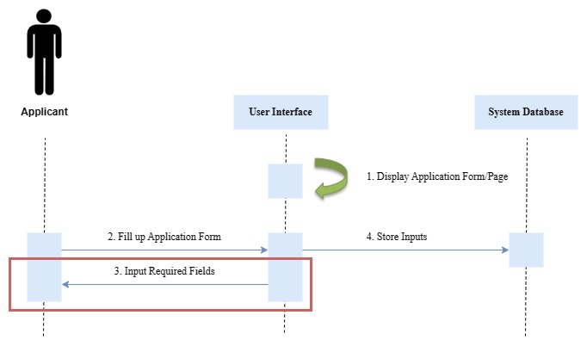*Figure 29.*** *Sequence Diagram for Applicant Application.*

**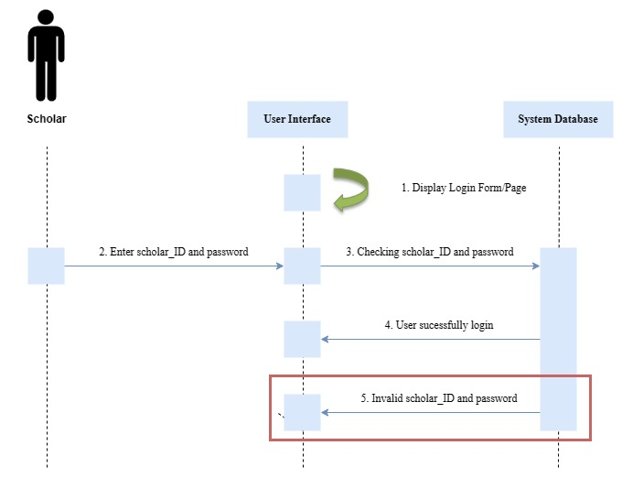*Figure 30.*** *Sequence Diagram for Scholar Login.*

**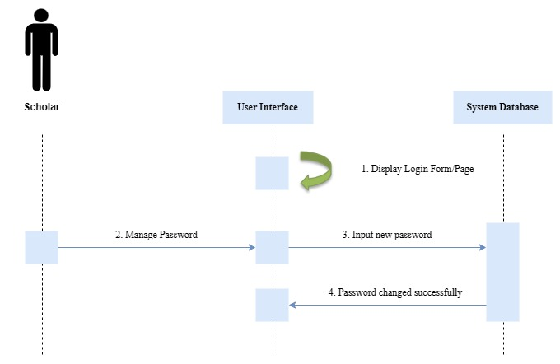*Figure 31.*** *Sequence Diagram for Manage Password.*

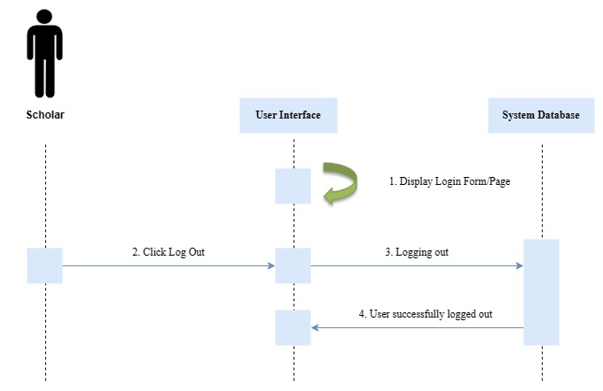

***Figure 32.*** *Sequence Diagram for Scholar Logout.*

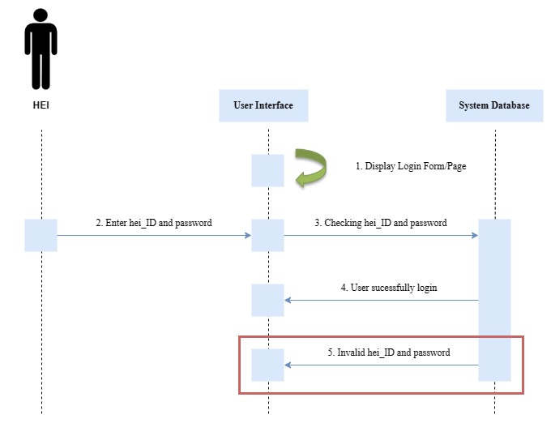

***Figure 33.*** *Sequence Diagram for HEI Personnel Login.*

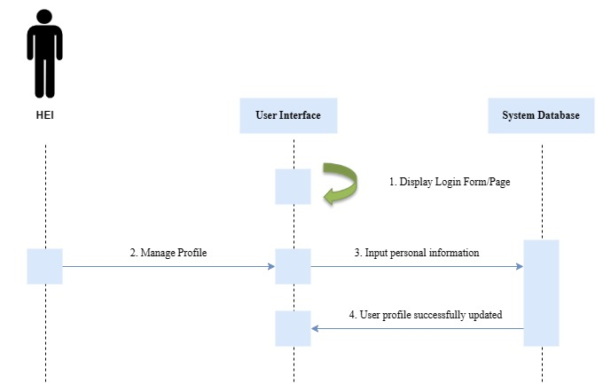

***Figure 34.*** *Sequence Diagram for HEI Personnel Manage Profile.*

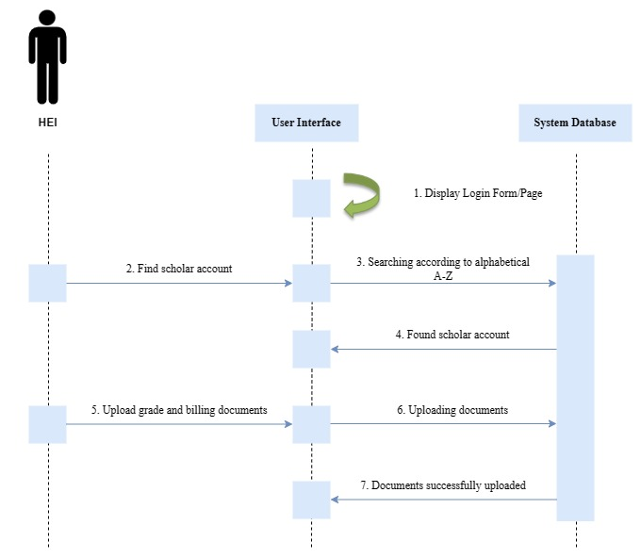

***Figure 35.*** *Sequence Diagram for HEI Personnel Manage Billing.*

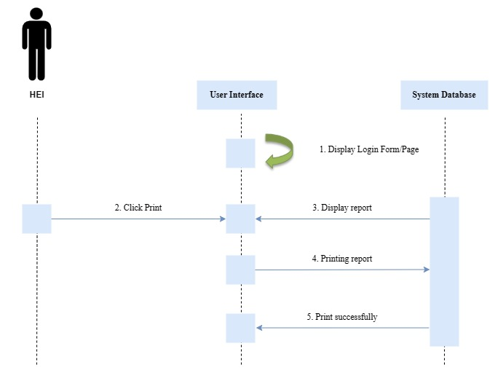

***Figure 36.*** *Sequence Diagram for HEI Personnel Print Report.*

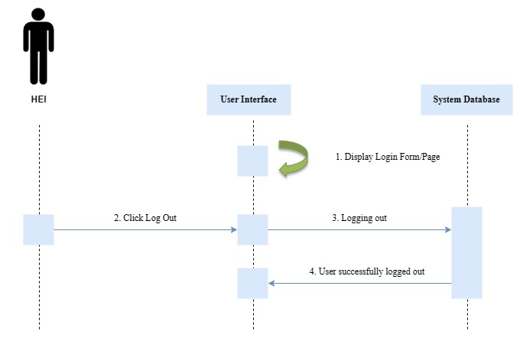

***Figure 37.*** *Sequence Diagram HEI Personnel Logout.*

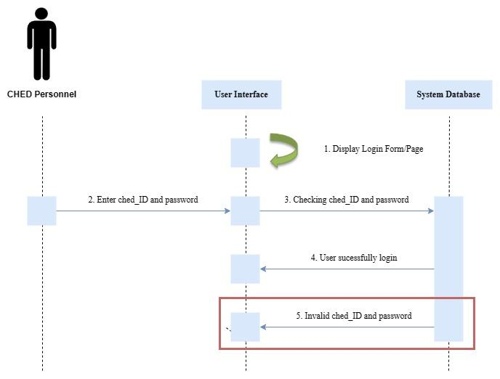

***Figure 38.*** *Sequence Diagram CHED Personnel Login.*

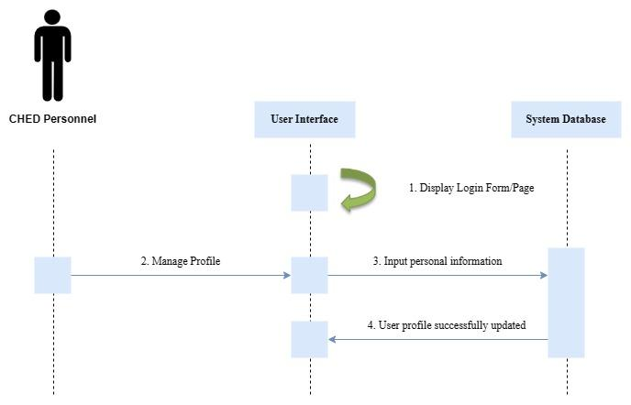

***Figure 39.*** *Sequence Diagram CHED Personnel Manage Profile*

**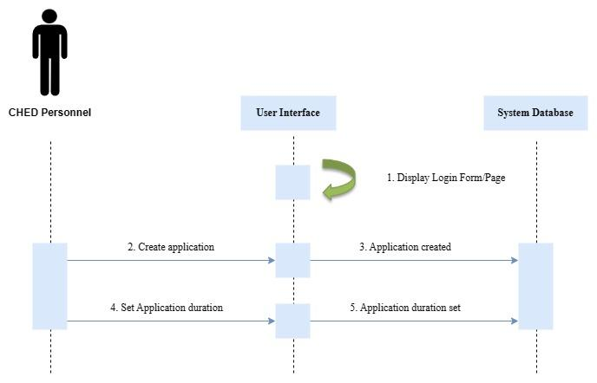 *Figure 40.*** *Sequence Diagram CHED Personnel Create Application.*

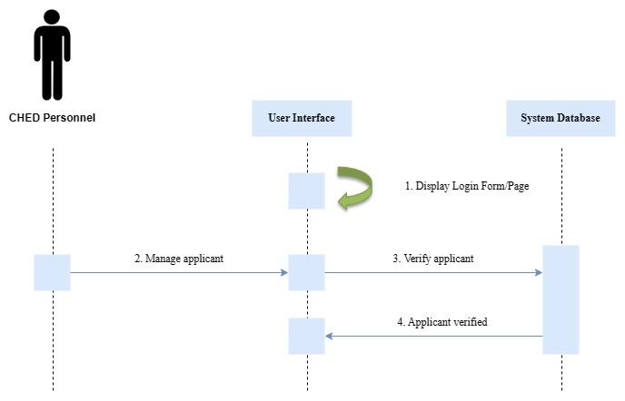

***Figure 41.*** *Sequence Diagram CHED Personnel Manage Applicant.*

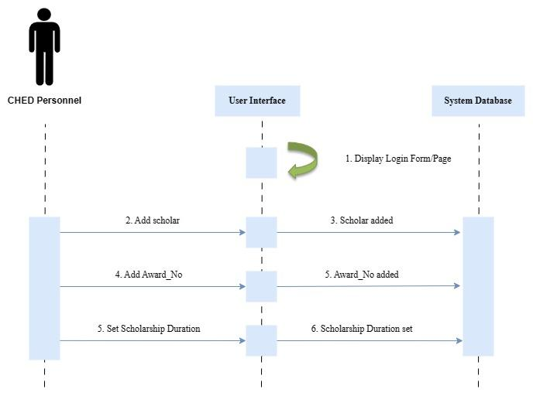

***Figure 42.*** *Sequence Diagram CHED Personnel Add Scholar*

**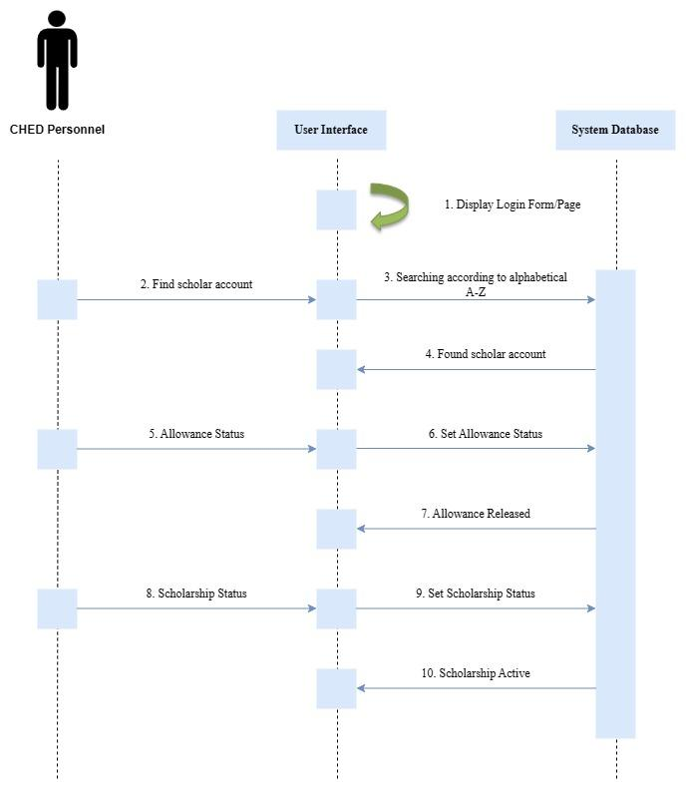 *Figure 43.*** *Sequence Diagram CHED Personnel Manage Scholar.*

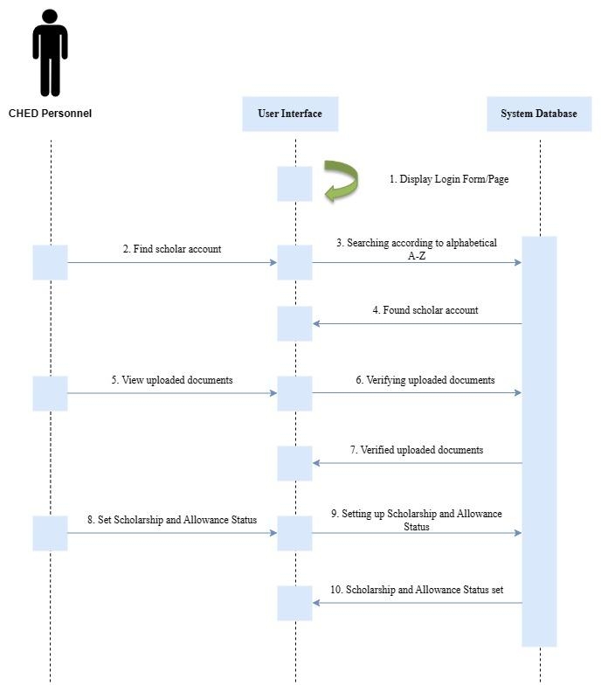

***Figure 44.*** *Sequence Diagram CHED Personnel Manage Billing*

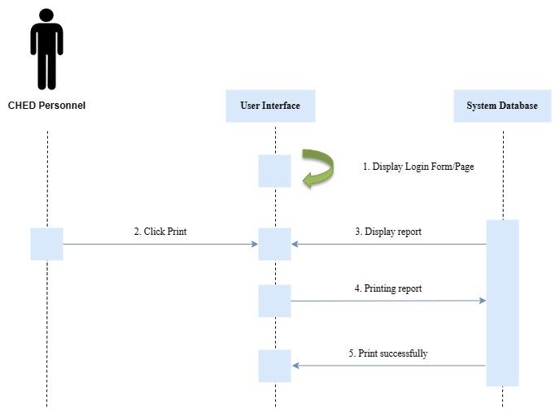

***Figure 45.*** *Sequence Diagram CHED Personnel Print Report.*

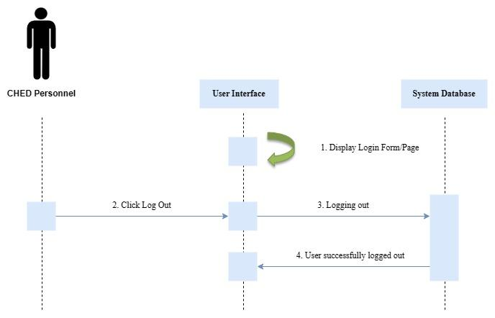

***Figure 46.*** *Sequence Diagram CHED Personnel Logout.*

**Chapter 4**

**RESULT AND DISCUSSION**

**Implementation of the Program Prototype**

**Project Description, Requirements and Specifications**

**ADD**

**Process Narrative**

This feature enables the scholarship applicant to add the following application information. Subsequently, the CHED Personnel add slots to the system, and the HEI personnel add the scholar’s grade and billing information. All data or information will be saved to the database automatically.

**Restriction/Limitation**

Only the CHED Personnel can manage the user information, add and update the scholars and HEI information. HEI allows to update the scholar’s status.

**Performance Requirements**

The admin is the only one who can view the information in the database system.

**Design Constraints**

The system will indicate that the information’s successfully added.

**EDIT/UPDATE**

**Process Narrative**

The feature allows the CHED Personnel to edit or update the scholar’s status. HEI also can update the billing and scholarship status of the scholars.

**Restriction/Limitation**

Only the CHED Personnel can update scholars’ termination.’

**Design Constraints**

The system will appear the information’s has been successfully updated.

**Reports**

**Process Narrative**

The system can generate reports to the Scholar Applicant, CHED Personnel and HEI Personnel.

**Restriction/Limitation**

Only the authorized user can view and access the report.

**Performance Requirements**

The system will provide a well updated reports for the authorized user.

**Design Constraints**

The system will give the authorized users a generated report.

**Database Functional Description**

This section contains detailed information on the data model used to support the functional requirements of the proposed system.

**Back-Up Consideration**

The system administrator is in charge of handling data backup. Once a week, system maintenance will be performed to protect the system and prevent data loss.

**Graphical User Interface and Features**

This graphical user interface and features are designed for three (3) different UI. (1) Scholar/Applicant, (2) HEI Personnel, and (3) CHED Personnel.

**Testing of the Program Prototype**

**Special Consideration**

For a system must be efficient, the researches specified the following considerations;

* The system will provide the User_ID and password for the users to avoid unauthorized access.
* The functions of each type of account may differ.
* The system can update their new passwords.
* All systems are required to use online via internet.

**Audit Trial and Transaction Facility**

The system has three user accounts: (1) The scholars, (2) the HEI Personnel, and (3) the CHED Personnel. Each user has different access in the system.

**Run-Time Testing, Debugging and Findings**

**Usability and User Testing**

**Software and Hardware Specifications**

Operating System - Windows 10 or above

Processor: Intel(R) Core (TM)-i3-4150 CPU @3.50GHz 3.50GHz or above

Ram: 8.0GB or above

Browser: Accessible to any kind of browser.

**Internet Connection**

• A minimum 50Mb connection is required

**Chapter 5**

**SUMMARY, CONCLUSION, AND RECOMMENDATIONS**

**Summary**

**Conclusion**

**Recommendations**

**APPENDICES**

**Letter of Consent**

**Certificate of Appearance**

**Certificate of Deployment**

**Figures and Plates**

**User Training and Program Deployment**

**Software Exhibit**

**Proposed Budget**

**Survey Questionnaires**

**Time Frame**

**REFERENCES**

Aliyu, A. M., & Abubakar, A. M. (2019). Scholarship Management System: An Overview. International Journal of Advanced Computer Science and Applications, 10(6), 541-546. <https://doi.org/10.14569/ijacsa.2019.0100653>

Jinto, J. S., & Bibin, B. M. (2018). Design and implementation of a scholarship management system. International Journal of Pure and Applied Mathematics, 119(18), 3023-3033. <https://doi.org/10.12732/ijpam.v119i18.24>

Al-Hawari, T., Alshawabkeh, Y., & Abu Nawas, I. (2019). Development of a Web-Based Examination Management System Using Java Technology. International Journal of Advanced Computer Science and Applications, 10(6), 9-18. <https://doi.org/10.14569/ijacsa.2019.0100602>

Seidu, R. (2017). Enhancement of a Web-based Scholarship Management System for a Non-government Organization in Ghana. International Journal of Computer Science and Network Security, 17(5), 239-246. <https://doi.org/10.1109/ICACCS.2016.7817017>

Falogme, A. A., Kodjo, V. N., & Selom, A. (2017). Scholarship Management System Using Microsoft Access: A Case Study of A Particular City's Scholarship Office. International Journal of Scientific and Engineering Research, 8(3), 1173-1181. https://www.ijser.org/researchpaper/Scholarship-Management-System-Using-Microsoft-Access-A-Case-Study-of-A-Particular-Citys-Scholarship-Office.pdf

Salleh, S. F., Ujir, H., & Hashim, H. F. (2020). Design and development of accreditation document tracking system (ADTS) using Scrum approach and Unified Modeling Language (UML). International Journal of Advanced Computer Science and Applications, 11(2), 265-273.

Omoregbe, N., Azeta, A., & Edeh, E. (2018). Creating and implementing an electronic file tracking system (EFTS) to enhance productivity among core administrative personnel. Journal of Theoretical and Applied Information Technology, 96(10), 3371-3381.

Kolte, M. (2021). A File Tracking System for the Railway Department using a Three-Tier Architecture. International Journal of Computer Sciences and Engineering, 9(6), 666-673.

Omoregbe, N., Azeta, A., & Edeh, E. (2019). Creating and implementing an electronic file tracking system (EFTS) to enhance productivity among core administrative personnel. International Journal of Computer Science and Mobile Computing, 8(5), 10-19.

Hendradjaya, E., & Sunindyo, W. (2017). Developing a Document Tracking Measurement Model to Support e-Government Business Processes. Journal of Theoretical and Applied Information Technology, 95(1), 216-224.

Sunindyo, W., Hendradjaya, B., & Widagdo, T. E. (2019). Integration of document tracking technology into e-government processes in Indonesia. Journal of Telecommunication, Electronic and Computer Engineering, 11(2-2), 121-126.

Puspitasari, N., Indrajit, R. E., Fauzi, R., & Darmanto, N. S. (2019). Factors affecting the utilization of an integrated licensing service information system: A case study of Samarinda City Investment and Integrated One-Stop Service. Journal of Physics: Conference Series, 1239(1), 012053. https://doi.org/10.1088/1742-6596/1239/1/012053

Ragueso, A. (2018). Big Data in healthcare: A review of literature. Journal of Healthcare Communications, 3(3), 1-7. https://doi.org/10.4172/2472-1654.100127

Carvalho, J. V., Costa, C. J., & Morais, P. (2019). A maturity model for hospital information systems data analytics. Procedia Computer Science, 164, 547-553. https://doi.org/10.1016/j.procs.2019.12.190

Guo, J. X. (2019). Evaluation model of information systems project management. Library and Information Service, 63(9), 50-58. https://doi.org/10.13266/j.issn.0252-3116.2019.09.006

Whitworth, B., & Zaic, S. (2018). A performance-based framework for evaluating advanced information systems. Journal of Management Information Systems, 35(1), 193-228. https://doi.org/10.1080/07421222.2018.1408353

Wagner, S., Suchan, M., & Frank, U. (2019). Analyzing and designing flexible information systems: A conceptual framework. Information Systems Journal, 29(4), 803-829. https://doi.org/10.1111/isj.12218

Hendriyati, P., Agustin, F., Rahardja, U., & Ramadhan. (2022). The use of information systems and integrated data management in academic matters. Journal of Physics: Conference Series, 1919(1), 012043. https://doi.org/10.1088/1742-6596/1919/1/012043

Azeroual, O., Saake, G., & Schallehn, E. (2018). Data profiling techniques for improving research information systems quality. Information and Software Technology, 103, 26-38.

Zia, M. F., Elbouchikhi, E., & Benbouzid, M. (2018). Microgrids energy management systems: A critical review on methods, solutions, and prospects. Renewable and Sustainable Energy Reviews, 82(Pt. 1), 426-437.

Dias, D., & Cunha, J. P. S. (2018). Wearable Health Devices—Vital Sign Monitoring, Systems and Technologies. Sensors, 18(8), 2414.

Fathi, M., & Abdelhalim, M. B. (2017). Autonomous Power Management of Smart Homes Using Distributed Energy Resources and Intelligent Energy Management System. IEEE Transactions on Sustainable Energy, 9(3), 1139-1149.

Esmaeilian, B., & Rezaei, M. (2018). A comprehensive review of thermal energy storage systems in energy production and consumption. Renewable and Sustainable Energy Reviews, 82(Pt. 3), 3470-3485.

Luo, H., Wang, C., Huang, L., Sun, H., & Gu, L. (2018). A New Energy Management System for a Grid-Connected AC/DC Hybrid Microgrid Based on Cascade PI Control. IEEE Transactions on Industrial Electronics, 65(7), 5479-5488.

Rizwan, M., Hussain, A., Ali, H., Imran, M. A., & Naeem, M. A. (2019). Energy management system based on efficient fuzzy logic control for hybrid renewable energy sources. International Journal of Electrical Power & Energy Systems, 108, 730-741.

Xu, L., He, Y., Lin, T., & Huang, X. (2019). Power management strategy of photovoltaic–battery–super-capacitor hybrid energy storage system. Applied Energy, 240, 534-548.

Zhang, Y., Li, Z., & Li, W. (2017). Intelligent Energy Management System of Microgrid With Energy Storage. IEEE Access, 5, 12213-12221.

Zhang, Y., Liu, S., & Zhang, J. (2018). Energy Management Strategy for Hybrid Electric Vehicle Based on Neural Network Control. In Advances in Intelligent Systems and Computing (pp. 311-320). Springer.

Zhao, M., Yan, W., & Miao, J. (2019). Real-time energy management strategy for hybrid energy storage system with supercapacitor and battery. IEEE Transactions on Transportation Electrification, 5(1), 212-222.